Contents
AGENDA 2
AGM 2025 MINUTES 3
MINISTRY REPORTS 6
CHILDREN’S MINISTRY REPORT 8
BOARD CHAIR REPORT 9
BOARD REPORTS 11
ADMINISTRATION & MINISTRY TEAM 12
AFFIRM TEAM 13
CHRISTIAN DEVELOPMENT TEAM 14
CHRISTIAN DEVELOPMENT 16
Messy Church Team 16
CONGREGATIONAL LIFE 17
Healing Pathway Team 17
FINANCE TEAM 18
GREEN TEAM 19
MINISTRY & PERSONNEL TEAM 23
OUTREACH TEAM 24
Central Alberta Foodgrains Growing Project 24
OUTREACH TEAM 25
Lacombe Food Bank 25
PROPERTY TEAM 26
UCW 1 27
UCW 2 28
WORSHIP TEAM 29
WORSHIP TEAM 30
Audio-Visual Team 30
CHURCH STATISTICS FOR 2025 31

AGENDA
ANNUAL CONGREGATIONAL MEETING
Sunday April 12, 2026
- Opening Prayer
- Welcome
- Voting
  - Motion: All present, member and adherents included, have the right to vote
- Agenda: additions, approval
- Minutes: Approval of the Congregational Meeting minutes of April 06, 2025
- Review of the 2025 Annual Reports
  - Motion to receive all reports for information.
- New Business
  - 2026 Budget
  - Sabbatical Report
  - Ministry Call Report
  - Legacy Fund Recommendations
-The Local Community Portion disbursement of The Legacy Fund in the amount of $_____ be provided to ______in Lacombe. Moved by Doug Maas, seconded by__________.
-The World Community Portion disbursement of The Legacy Fund in the amount of $_____ be provided to ______. Moved by Doug Maas, seconded by____________.
- Elections
  - Presentations of committees and vacancies
  - Nominations from the floor
  - Election of Board Chairperson for 2026 - 2027 (1-year)
Motion: I,__, nominate __ to be the Chair of the Board for the term of 2026 to 2027, seconded by
  - Election of Finance Representative.
Motion: I,__, nominate __ to be the Finance Representative Board for the term of 2026 to 2027, seconded by
  - Chinook Winds Regional Representatives (Up to two) (1-year)
Motion: I,__, nominate __ to be the Chinook Winds Regional Representative for the term of 2026 to 2027, seconded by
  - Trustees for 2026 (Board Chair, Chinook Winds Regional Representative, Finance Chair, Property Chair (1-year)
- Appointment of Independent Internal Examiner
- For Information:
  - Volunteer Link Representative: Bob Settle
  - Members of the M&P Committee (appointed by the Board) Barry Brouwer, Bob Jenkins and Ron Gish
- Motion to destroy ballots (if needed)
- Announcements and Courtesies:
- Closing prayer
- Adjournment

AGM 2025 MINUTES

Annual Congregational Meeting Minutes
St. Andrew’s United Church
Sunday, April 6, 2025

St. Andrew’s United Church Annual Congregational Meeting was held in the sanctuary on Sunday, April 6, 2025, following a potluck luncheon. There were 54 in attendance. See list attached. Bryant Burnard called the meeting to order at 12:25 PM. Jana Figursky was recording secretary.

- Opening Prayer – Reverend Barbara Lieurance

- Welcome – Bryant Burnard welcomed the congregation to the AGM.

- Voting
  - Motion A1/2025: All present, members and adherents included, have the right to vote. William Langille, Jane Wilkinson. Carried

- Agenda - Doug Maas added an addition to 7b Legacy Fund recommendation. Motion A2/2025 to approve the Annual Congregational Meeting Agenda for April 6, 2025. Sandra Smith, Donna Gish. Carried.

- Minutes – Motion A3/2025 to approve the Congregational Meeting minutes of January 28, 2024. Tilly Meyer, Geke Bruning. Carried

- Review of the 2024 Annual Reports: printed and oral
  - Motion A4/2025 to receive all reports for information. Ron Gish, Sarina King. Carried

- New Business
  - 2024 Budget Review and 2025 Budget. Hans Haefliger reviewed the 2024 finances. We ran a deficit of $18,000 in 2024 which was good considering inflation.
Motion A5/2025 to accept the 2025 budget. Hans Haefliger, Ko Bruning. Carried

  - Legacy Fund Recommendations: Doug Maas presented the following Outreach Team recommendations:
Motion A5/2025 Moved that the Local Community Portion disbursement of the Legacy Fund in the amount of $1394.00 be provided to the Broom Tree Foundation in Lacombe. Doug Maas, Alida Burnard. Carried
Motion A6/2025 Moved that the World Community Portion disbursement of the Legacy Fund in the amount of $1394.00 be provided to the United Church of Canada - Gaza Appeal. Doug Maas, Bob Settle, Carried

Motion A7/2025 Moved that the congregational portion disbursement of the Legacy Fund in the amount of $3010.00 be provided to the Green Team Tree Planting Project. Doug Maas, Bob Settle. Carried

  - Proposed change to board structure:
Motion A8/2025 The Governance Committee moves that the Proposed Governance Policy for St. Andrew’s United Church 2025 be adopted into practice as of April 6, 2025, and that this be reviewed at the 2026 AGM. Darryl Langille, Karen Yakimishyn. Carried

  - Vision Team resolution Motion A9/2025 to approve the proposal of the Vision Team to forward to the Board: Ron Gish, Lawrence Hrycan. Carried

  - Initiate the search process for ministry staff:
    - Motion A10/2025 Moved that a discernment committee be created to determine St. Andrew’s needs for a second staff member. Dave Hnatiuk, Donna Gish. Carried

- Elections
  - Motion A11/2025 Moved that we vote for member vacancies as per the new Board structure decided at this meeting: Paul McCaskill, Alida Burnard. Carried

The following names were put forth by the Nominating Committee: Bryant Burnard, Board Chair; Karen Yakimishyn, Treasurer; Barry Brouwer, Chair of Ministry & Personnel; Hans Haefliger, Chair of Finance; Lawrence Hrycan, Chair of Property; Chinook Winds Regional Representative: Dave Hnatiuk and Alida Burnard; Members at large: Gail Wilson and Paul McCaskill. No names were put forth by the Nominating Committee for Secretary. Nominations were asked for by the Chair for all positions. No further names were brought forward.

  - Motion A12/2025 Moved that nominations cease and that the names presented be accepted for the board of St. Andrew’s for 2025.: Bob Settle, Sarina King. Carried.

  - Motion A13/2025 Moved that the board be empowered to look for and appoint a recording secretary. Lawrence Hrycan, Darryl Langille. Carried

  - Moved that the Trustees for 2025 be the following: Board Chair, Chinook Winds Regional Representative, Finance Chair, Property Chair. Doug Maas, Linda Hueppelsheuser. Carried

- Appointment of Independent Internal Examiner: Motion A14/2025 to continue with Sandra Radau as the Independent Examiner for 2025. Karen Yakimishyn, Hans Haefliger. Carried

- For Information:
- Volunteer Link Representative: Bob Settle
- Members of the M&P Committee (appointed by the Board) Barry Brouwer, Karen Yakimishyn, Sandra Smith-Bernatsky and Ron Gish

- Announcements and Courtesies: Howard Woodrow thanked the St. Andrew’s board and committees, remarking that the entire meeting centered around the “future of St. Andrew’s” which he sees as a very positive thing.

- Closing prayer – Reverend Dave closed with prayer.

- Adjournment – Meeting adjourned at 2:58 PM.

MINISTRY REPORTS
Reverend Dave Holmes

I remember the beginning of 2025 being quite busy. We were working towards our annual general meeting, which was later than usual to give us time to prepare the essentials – budgets, financial reports, and proposals for our new governance structure and our mission and vision statements. The Green Team was preparing for work on the Woodland Sanctuary as our primary project for the 100th anniversary of the United Church. And we were also hosting the AGM for Chinook Winds Region.

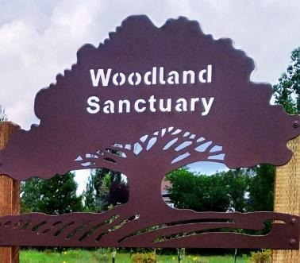
All of these major projects went very well, from my perspective! The Green Team (and all its many partners and donors) not only managed to create a unique space for Lacombe, but also created a network of partnerships and engaged a lot of people outside of our church. The two teams (researching and writing new identity statements, and writing policy for a new governance structure) took very difficult jobs and made them look almost easy. Both changes passed overwhelmingly at our AGM, and now we need to get used to the new systems. We have made changes, both to our mission/vision and to our governance, but I think the changes are not in essence. We have refined our vision but we’re still moving in the same direction we have been; we have changed our governance system but we are still working to empower our ministry teams, and allow practical decisions to be made by those who are actually doing our various ministries.
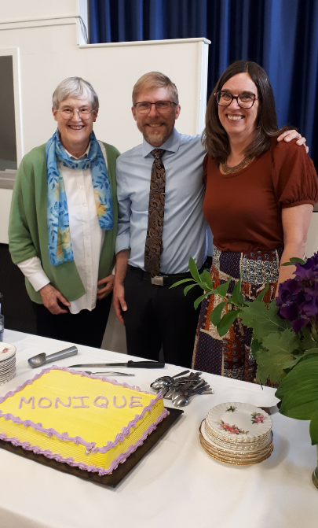
Many thanks to the vision and policy teams, to our new board as they forge some new habits. Thanks to the Green Team and everyone who pitched in, both with shovels and with financial support. Thanks to all who pitched in to help with the Chinook Winds AGM – folks were very pleased. And thanks to our financial people, who have also had a very full year, switching from a computer system that had become dysfunctional to something we hope will work much better. Karen, Shannon, Hans, Linda, Alida and all the finance team – thank you for all those hours of back-office work!

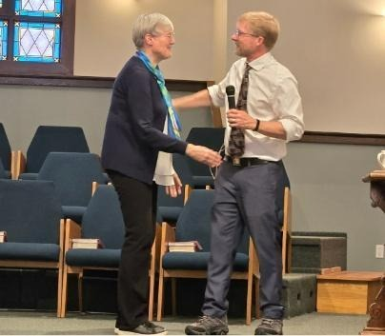
Summer brought some significant changes. We said a number of very, very significant good-byes. Norm and Evelyn, Helen, Florence, and Monique all moved away from Lacombe, for a variety of family reasons. In a church like ours, there are always significant folk who pass away, each year, and 2025 was no different. And of course, Barbara retired.
I’ve been here long enough now to feel these losses very personally; this is the hard part about church. But I am also profoundly grateful for all that these people brought to this community of faith. Working with Barbara has been a very great privilege. Dennis was a valuable mentor. Each of the people who have moved had their own integral part of the strength of this church. We are blessed.

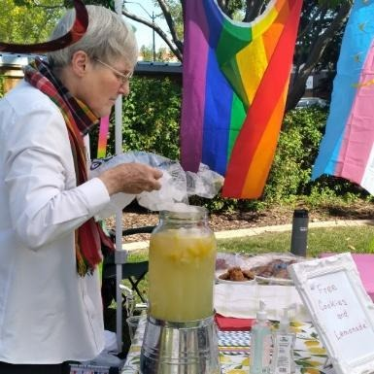
And there is newness as well. We’ve welcomed Brenna onto the staff, and have discovered that, amazingly, she is as warm and kind and wonderful as Barbara! And she has her own set of skills and gifts. For the first time, in 2025, we were invited to have a booth at the Pride festival in the summer, and offered blessings, cookies and lemonade – and I hope began to build some bridges. We began a Bible study offsite, at Blindman Brewing, and are beginning to be known in a very different place and crowd. Our Sunday school seems to be growing, and a youth group is being formed… I am so pleased once again to say that I just can’t list all the good things that are happening in this church – committees to potlucks to breakfasts and walks, music and worship…

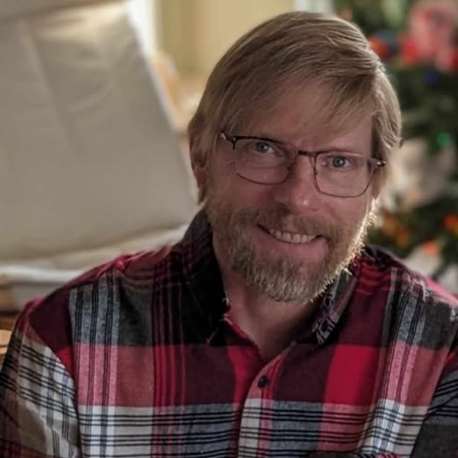
One thing I should report: we began a conversation (a difficult one) about drag shows, and the possibility that we might provide space for regular drag shows here in our church hall. The conversation started in the fall of 2024, and continued in bits and pieces in 2025. I’m very proud of this church for entering into this conversation in good faith – folks have said what they need to say with respect and care, and they have listened as well. It also looks as if the conversation is done, at least for now. We never did get a formal proposal, and at this point I’m not sure we will. But thanks for leaning in to a difficult conversation in a good way. It’ll set us up well for the next time we need to talk about something difficult – and I’m confident there WILL be a next time and that it will be fine!

Thanks to all of you; I am each week, each day, thankful to be involved with such a fine church. You’re wonderful people, you have built a great community of faith, and you make such a difference in this place. Thank you and bless you all!

CHILDREN’S MINISTRY REPORT
Brenna Trimble

Last year saw many changes within the children’s programs at St. Andrew’s. Reverend Barbara Lieurance announced her retirement in the Spring, and the congregation and young families had to prepare to say goodbye and discern how family needs would be met in her absence.

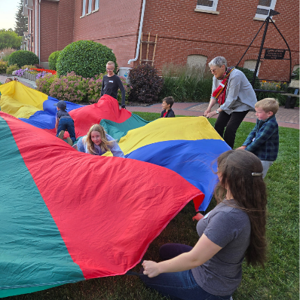
Prior to her official retirement at the end of August 2025, Barbara organized, with the help of many dedicated volunteers, an amazing Summer Camp experience. Participants came for three fun-filled evenings at the church, during which they got to play, sing, craft, and learn about God’s love. The St. Andrew’s Summer Camp crew even got to decorate a float for the 2025 Lacombe Days Parade and join in the parade!

The Fall saw a period of transition and questioning amongst the young families of St. Andrew’s. Barbara had been such a strong connection point and the driving force behind Sunday School and the welcoming familial atmosphere of St. Andrew’s.

The Church made the decision to hire an interim Children’s Programming Coordinator so that Sunday School could resume while bigger hiring questions remained to be answered. Congregant Brenna Trimble applied for and was hired for the position. Her background in Education and desire to keep kids in church lent itself to the role.

The families and volunteers of St. Andrew’s rallied together and ensured that our church remained a place for families. Weekly Sunday school is now regularly attended by nearly a dozen kids, and new families have become familiar faces in our pews.

Annual activities like the Easter Egg Hunt and Christmas on the Farm, organized by the Christian Development Team bring young and old together in refreshing ways and add exciting ways to connect with one another.

The Messy Church Program continued to thrive, hosting a popular evening once a month that draws both familiar and unfamiliar families in the door for a night of food, fun, and fellowship. As part of her role, Brenna Trimble joined this planning committee in order to ensure the continuance and support of Messy Church.

In January of 2026, the youth of St. Andrew’s committed to meeting with one another each month, and our first Youth Group night with this new generation was launched! Their Youth Group has a focus on fun and team bonding, while also working on projects that grow their faith (like hosting a Worship Service) and allow them to engage with the community (assisting the Green Team with spring clean up).

Overall, it has been a roller coaster year for the Children’s Programming and families of St. Andrew’s. As we look to the future, it is with hope of a strong Sunday School program, an active Youth Group, a sought-out Messy Church Program, and another inspiring Summer Camp. Stay-tuned!

BOARD CHAIR REPORT
Bryant Burnard

Another year has slipped by and here we are at the Annual General Meeting. Again, I must thank the wonderful pool of talent we have at St. Andrew’s.
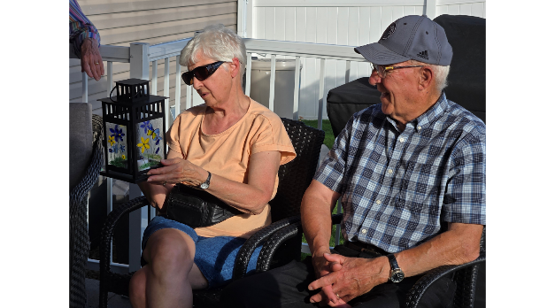
Our Property Committee continues to keep our physical property in wonderful condition. We will miss the careful tending of our lawn by Norm Start this upcoming season, thank you for your years of service in doing this task. There is a retired Gentlemen’s club who go around and putter, keeping our furnaces/lights/security systems working.

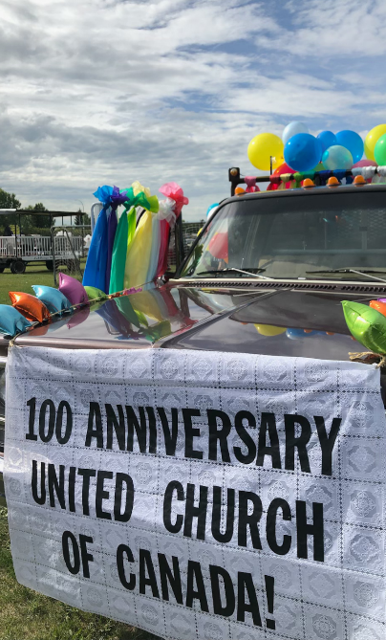
Our Congregation is transforming, but change isn’t a bad thing. In talks with Lawrence, our in-person presence is not always our largest group of people attending the Sunday Service. We have a growing on-line presence. Providing access to the Sunday Services to those who can not make it to the physical building, has been a wonderful addition.
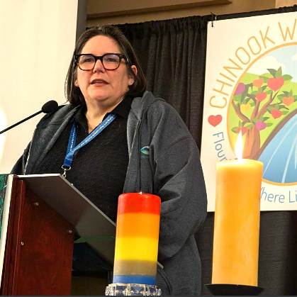
The hundredth anniversary of the United Church of Canada was observed in St Andrew’s several ways. Dave wore older vestments on several Sundays. Older hymns were sung during the services too. Our church was selected to host the Chinook Region Conference. Several members of the congregation were able to attend some of the conference sessions and found them very interesting. A highlight of joint Sunday Service was having the (Now Past) Moderator, Carmen Lansdowne providing the sermon. Being able to observe the Ordination of three new clergy members was wonderful too.

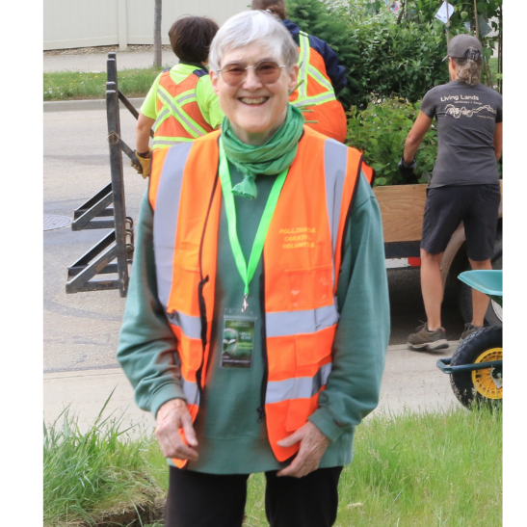
We also marked the retirement of Barbara Lieurance at the end of August. We all miss her presence in the church, and her warm smile.

A Needs Assessment committee was formed to look at what St. Andrew’s wants as the ministry of our church. It was recommended we look for a part time clergy position. At a Congregational meeting we voted to first look for a part time (35%) Ordained clergy to provide Pastoral Care role. The congregation also decided that if we didn’t have any suitable applicates, the search will expand to include designated lay people to provide Pastoral Care.
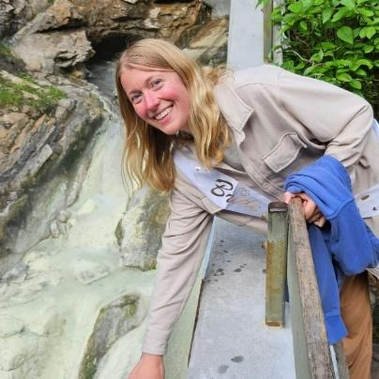
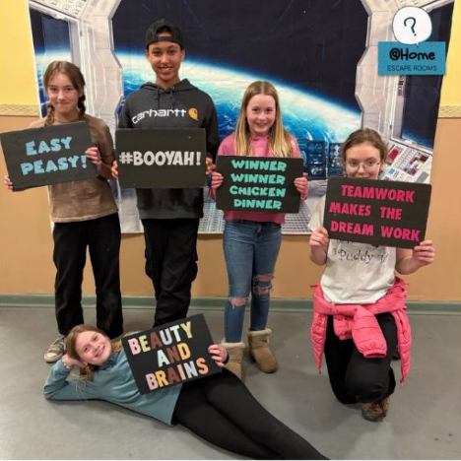
In exciting news Brenna Trimble has transitioned from being a temporary Children’s Program Coordinator position, to our part time Children's Program Coordinator. She has been leading an expanding Sunday program and started up the Youth Group last fall.

Tuesday’s have become a favourite day of the week for some of the congregation, meeting with the Bible study group at the Blindman Brewery. I personally have found the discussion of the Bible passages before the service to be very helpful, providing insight to the message within the Sermon. Please feel free to drop in, at the brewery most Tuesdays at 4:45 PM. You can pick up a beverage of your choice before joining the group. Please note, there are non-alcoholic beverages available too, with the Cranberry Lemonade being very popular choice. We usually meet upstairs.

This year the Board has been working towards using a new governance structure. Overall, this new structure has been a great change. One of the major changes has been moving a consensus-based voting system, instead of a straight majority. We are becoming more proficient in our meeting structure but must remind our selves of what the board should be worried about, and what the teams can manage on their own. This upcoming year we hope to have more time to reflect on where we see St. Andrew’s will be in the future.

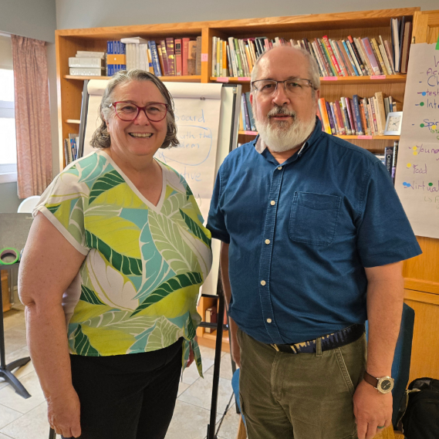
Wishing you all a wonderful upcoming year.

BOARD REPORTS
Legacy Fund

The Legacy Fund acts as a quasi-endowment fund for St. Andrew’s.
One half of all new donations each year stay in the fund to grow it, while the other half is eligible for distribution. A donor may request the full donation remain in the fund. All income earned on the fund is eligible for distribution.

The disbursement money available is allocated 40% for use of Our Community of Faith, 30% for use of the Lacombe and area community, and 30% for the larger world community. The Community of Faith portion cannot be utilized for items of an administrative nature.
Disbursement motions are voted on at the Annual General Meeting (AGM).

In 2025, $2,580.00 was donated through the church office to The Legacy Fund. Interest income earned was $1,657.01. Total eligible for distribution at the 2026 AGM features $1,175.00 for St. Andrew’s, $885.00 for the Lacombe and area community, and $885.00 for the World Community.

The balance of the fund as of Feb. 28, 2026 is $73,534.31.
Doug Maas and Ko Bruning are the members of The Legacy Fund team. Always welcome to take questions from the congregation.

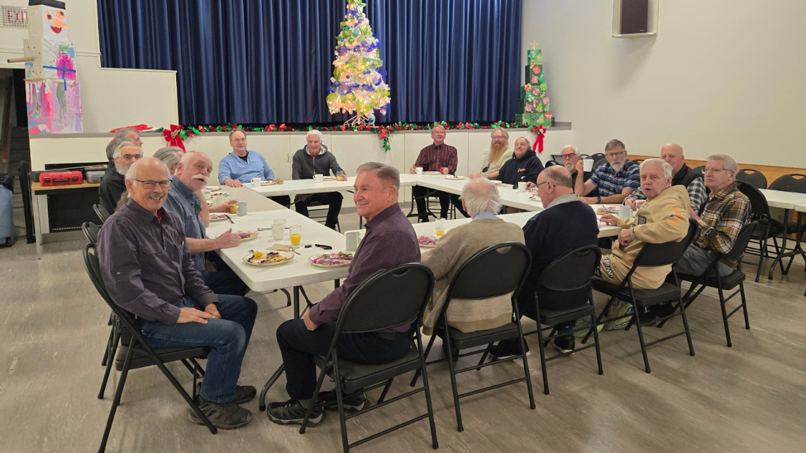

The Men’s Breakfast Group meets monthly in the hall for a delicious breakfast enjoyed by all!

ADMINISTRATION & MINISTRY TEAM

The Administration and Ministry Team is one of the new aspects of our governance structure that we approved at our annual meeting last year. Consisting of our called minister(s), property chair, and finance chair, the A&M Team is responsible to the board for most of the practical day-to-day decisions in the life of the church and building.

Here’s how it works, in theory: the Board is ultimately the key decision-making body in the church, as empowered by the congregation. But we are trying to free the board to do mostly strategic planning and longer-term visioning. So the Board will spend most of its time, we hope, on goals, plans, and conversations about what’s going on in the world and how that affects our life and mission. The Board, basically, is concerned with “ends” (where are we going) and it delegates decisions about “means” (how will we get there) to the A&M team.

The A&M team is responsible to the board for these decisions, but practically speaking, we expect those decisions to be made mostly by the ministry teams that are involved in the ministries. So decisions about the building are mostly with the Property Team, decisions about educational ministries and children’s ministries will be mostly with CD, worship decisions with the Worship Team, and so forth. We on the A&M Team report what’s going on to the Board, and help with communication between teams, and are there to co-ordinate work that involves multiple teams.

Much of this past year we have been trying to learn the system – who makes what decision, how we manage reporting and meeting – just getting used to our new role (hopefully without adding a whole pile of new meetings). In general, I think we appreciate being able to make decisions more quickly (for instance, about repairing or upgrading AV equipment necessary for livestreaming worship), without needing a board meeting; however, we will need to be careful about our communication with finance people, and ministry teams, as these decisions are made.

In the fall we did receive three goals from the board:
- Present a plan to improve the accessibility of our building with a particular emphasis on the physical accessibility to the sanctuary
- Present a plan for use of the St. Andrew's building that fits with our values and missional priorities
- present a plan to maintain financial sustainability over the long term

A&M struck three committees to develop these plans, which have been working since the later fall. We expect plans to be presented back to the board prior to our annual congregational meeting.

With gratitude,
Hans Haefliger, Dave Holmes, Lawrence Hrycan

AFFIRM TEAM

St. Andrew’s is an affirming church that embodies God’s unconditional love by welcoming all people regardless of sexual orientation, gender identity, ethnicity, social circumstances, ability or age.

The Affirm Team is a diverse group of people who are committed to support and nurture our congregation’s commitment to being an affirming church by providing leadership, educational and advocacy opportunities for the congregation.

Thank you to Monique Vermegen for all her hard work with the Affirm Team over the years. Her ideas, energy and personality have been greatly missed.

Thank you also to Rick Schmidt for stepping up and taking the lead of the Affirm Team for the rest of the year. His contributions and hard work are very much appreciated.
We have a bulletin board in the auditorium where we post information about activities and priorities that the Team want to highlight. Look for the colourful border on the bulleting board and check out the information posted there.
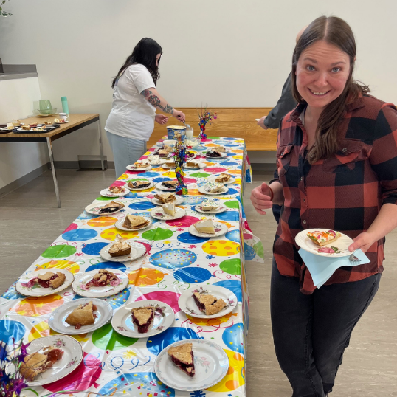
We celebrated National Affirming PIE Day on March 16, 2025. This event encourages congregations to be Public, Intentional and Explicit about the inclusion of 2SLGBTQIA+ people. The 2025 theme of PIE Day was “Sing Out Proud” and the choir led us in a new hymn, Sing a New World into Being, during the service. We had a selection of pies at coffee time after the service to continue in the celebration.

In August the Affirm Team was invited to have a booth at the Pride in the Park event put on by Lacombe Pride. We took our tent over to the park and decorated it. We offered glitter blessings, lemonade and cookies for those who stopped by. We also had copies of the book Colors of Hope: A Devotional Journal from LGBTQ+ Christians to give to people who wanted a copy.
We were represented at the Involvement Fair after church on October 26 along with all the other teams and groups in the church. It was a fun time, letting people know about our team and what we do. We had several people sign up to help us during that event. We are always excited to welcome new members to our team.

The Affirm Team hosted a movie night on November 28. We showed the 2018 release of The Grinch and had snacks and drinks available. There was a good crowd that attended. It was a wonderful family event.

We had a potluck supper for team members and their families in December. We had a fun time socializing and celebrating the Christmas Season.

CHRISTIAN DEVELOPMENT TEAM

The Christian Development Committee is an energetic and enthusiastic committee whose purpose is to support and nurture faith-based learning for young and old. We support a variety of programs and are always looking for ways to expand our faith focus within the church.
Members: Teri Lynn Amundson, Annerie Dunnewind, Lawrence Hyrcan, Claudine Bruning, Kasha Levi, Brenna Trimble, and Dave Holmes.

Christian Development at St. Andrew’s continues to be a vibrant and life-giving part of our church family. Through adult learning opportunities, children’s programs, intergenerational events, and faith formation, we are blessed to see people of all ages growing in faith, connection, and community.

We joyfully support adult learning initiatives led by our Minister, including Fresh Start in Faith, Book Studies, Sunday School, Summer Camp, and Messy Church—each creating space to learn, ask questions, build relationships, and deepen our walk with Christ.

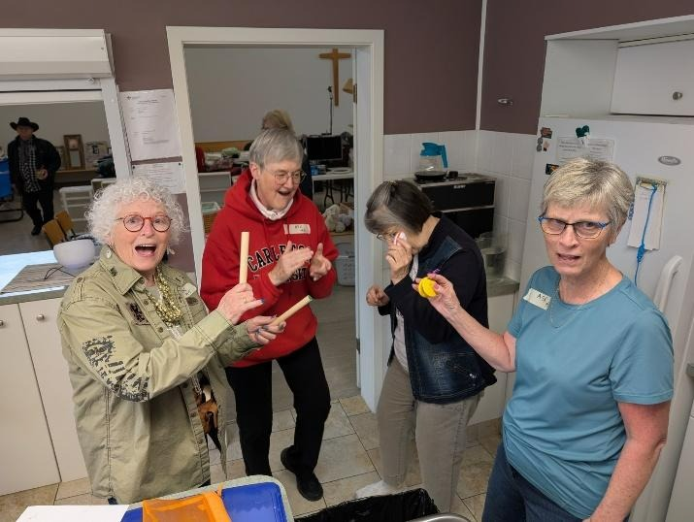
We kicked off the spring with our much-loved Annual Easter Egg Hunt, and it was a wonderful success! We had a great turn out and decided to offer two age-appropriate experiences, older kids and younger ones had a hunt that was for their skill level. Our older children took part in an exciting rhyming scavenger hunt throughout LMC Park and back to the church, while our younger children delighted in searching for hidden eggs in the sanctuary and downstairs.

Our Garage Sale, Bake Sale, and Lemonade Stand was another highlight, raising $4069 This year, every dollar raised is going to our Green Team. It’s often said that volunteers are the backbone of any great mission. But I believe you are more than that—you are the heart. And this week, this church beat stronger because of you.

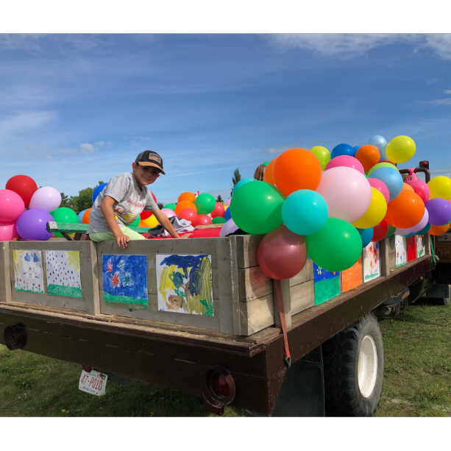
This year, we tried something new by hosting Summer Camp in the evenings, and it was a wonderful success! The later time worked beautifully for families and created a relaxed, joyful atmosphere. We had so much fun getting creative together, especially while designing and decorating our parade float. The laughter, teamwork, and excitement made it a truly memorable experience for both the children and volunteers—and a great way to share our church spirit with the wider community.

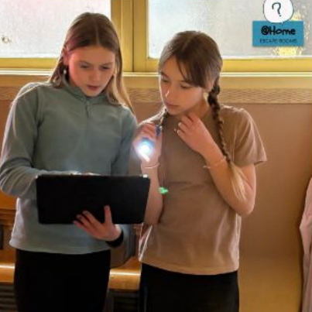
We are so grateful that Brenna has stepped into the role of Sunday School teacher, taking over from Barbara and doing a wonderful job. The children are thriving under her leadership, and it is a joy to see her passion, creativity, and heart for teaching shine each week. She brings fun, engaging, and meaningful lessons that the kids truly look forward to. New this year, Brenna is also launching a Youth Group for Grades 5 and up, creating an exciting new space for our older children to connect, grow in faith, and build community together.

We are also delighted to see our Sunday School numbers growing this year. It has become the norm to welcome 10 or more children each Sunday, which is such a blessing and a wonderful sign of life, growth, and young families feeling at home at St. Andrew’s.

This year, we began a Tuesday afternoon Bible Study at the Blindman Brewery Taproom, and it has quickly become a meaningful and well-loved gathering. Focusing on the scripture text for the upcoming Sunday’s worship, this group has consistently drawn 5–10 participants nearly every week. It has been a wonderful space for open conversation, learning, laughter, and growing together in faith in a relaxed and welcoming setting.

We are also grateful for the work of other groups within our church, notably the Living Into Right Relations group, who periodically offer educational events and learning opportunities. Their commitment to deepening understanding, fostering reconciliation, and e ncouraging thoughtful faith engagement is an important and valued contribution to our Christian Development ministry.
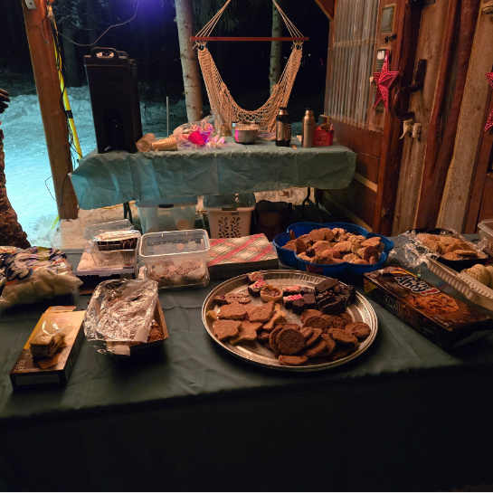
We closed the year with our 5th Annual Christmas on the Farm at Paxton and Alissa Morisson’s wonderful acreage. With over 40 people in attendance, this special evening under the stars, surrounded by fellowship, hot chocolate, and delicious cookies, was a beautiful way to prepare our hearts for the New Year. This event has become a treasured tradition enjoyed by all ages.

We are truly blessed at St. Andrew’s to have such an energetic, creative, and dedicated group of volunteers who work tirelessly to make our church a welcoming, engaging, and faith-filled place. Without them, many of these programs simply would not be possible.
If any of these ministries speak to you, or if you feel a nudge to get involved, we would love to hear from you. Please contact the Christian Development Committee or the church office—we would be thrilled to welcome you into this meaningful work.

CHRISTIAN DEVELOPMENT

Messy Church Team

We held our first Messy Church in October 2013 and December 2025 was our 94th Messy Church. The overall theme of 2025 for January to May was “Community” and the overall theme for September to December was Stories from the Bible. The monthly themes were:

January Animals in our Community Psalm 23
February Family/Friends Luke 10: 1-11
March Exploring our Community Acts: Chapter 2
April Easter Story of Ernie and Alice
May Camping: Outdoors in our Community Matthew 6: 25-29
September Loaves and Fishes John 6
October The Widow’s Offering Mark 12: 41-44 Luke 21: 1-4
November A Call Story Moses and the Burning Bush
December The Christmas Story

As many activities do at St. Andrew’s, Messy Church relies heavily on volunteers. This year, in addition to many adult volunteers, 10 youth from St. Andrew’s and the community contributed their time in making this prayer and gathering time successful.
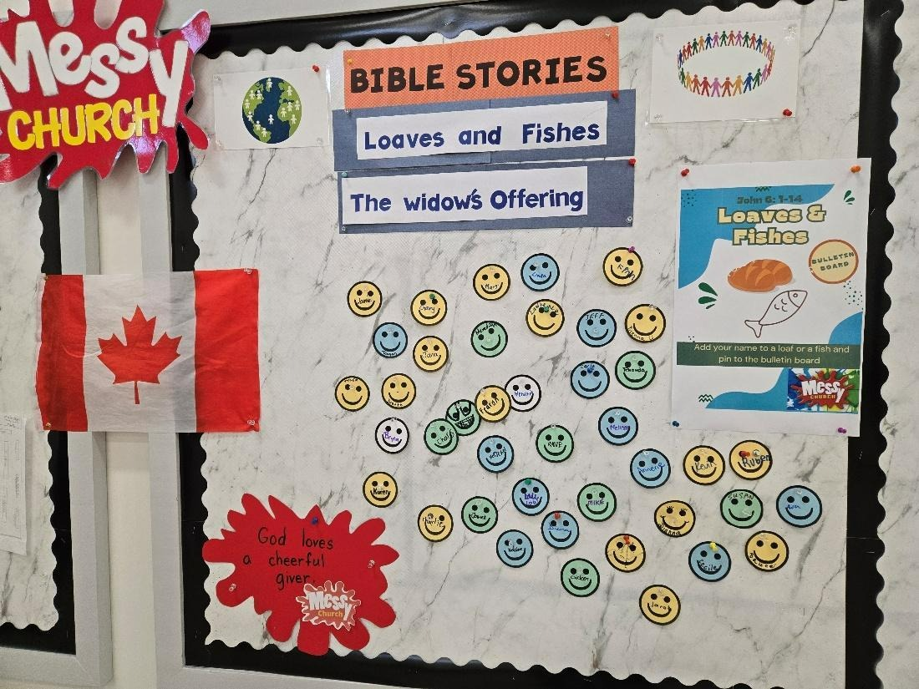
Families who participate have told us that they appreciate the youth involvement with their children.
This ministry runs from 5 to 7 p.m. the first Friday of each month. The participants are greeted and welcomed at the door, directed to the prayer station and the bulletin board and then on to other activities. From 5 to 6 p.m. everyone becomes involved with arts, crafts, and activities geared towards the monthly theme. At 6 p.m. we all move into the Sanctuary where the minister or a facilitator tie everything together in a lesson. St. Andrew’s is blessed in that both Reverend Dave and Reverend Barbara take part in the service. Not all Messy Church programs have ministry personnel involved. We sing 2 or 3 songs, say grace, and then move back to the auditorium for a meal and fellowship.
Volunteers are always welcome, whether it be assisting with a craft, a story, a game, a song, or with the food in the kitchen. Including our food preparation planning individuals, there were 17 adults and 10 youth who volunteered. Everyone is welcome to come and simply see what the buzz is all about. Feel free to come and take part in this monthly Messy Church program.

CONGREGATIONAL LIFE

Healing Pathway Team

The Healing Pathway Ministry team at St. Andrew’s is a dynamic group. It offers free healing sessions on the first and third Monday of each month, October through June. Healing sessions are by appointment at 7:15 pm and 8:00 pm. These sessions are open to anyone from the congregation or the community at large. Contact information is posted on a slide presented before the start of church as well as on the church’s website under Ministries: Healing Pathway. Information about the Healing Pathway ministry is provided via brochures available at the back of the sanctuary and on the church’s website.

The year was a busy one for the HP group. In March, the group ran an information session; as a result, four people joined the HP team! An introductory instructional session was held for these new members a few weeks later. One new member attended the Healing Pathway Phase One session in Lethbridge and was certified for this level by The Healing Pathway Society. Our Healing Pathway group has been mentoring all these individuals through instructional sessions and practice, and this will be ongoing. New members are welcome at any time! Contact the office or any HP group member.

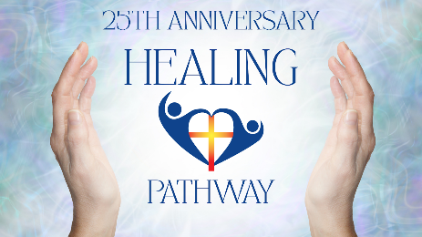
The HP Group members continue to offer a blessing to the minister prior to the Sunday service and to offer blessings to anyone who comes to the blessing station at the back of the sanctuary during Communion. Twice this year, we took our turn volunteering for the church’s coffee time. We celebrated our yearend in June and the Christmas season in December with get-together meals. In September, the St. Andrew’s United Church Healing Pathway group celebrated its 25th anniversary and participated in a Healing Service led by Rev. Dave Holmes. In October, the HP group participated in the church’s Involvement Fair. In December, group members prayed with individuals during the Blue Christmas service.
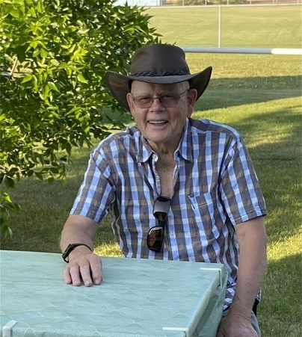
While our group has increased in size, we were sad to lose a valuable and dedicated team member… Dennis Hueppelsheuser. The HP group recognized his commitment and contribution to the group through an evening session of readings and prayer.

There continues to be an interest in the many healing energy benefits the Healing Pathway offers, and the group had been busy filling this need. The Healing Pathway group remains committed to providing this healing ministry to St. Andrew’s United Church and the community.

Respectfully submitted, Marlene Ayer

For the Healing Pathway Group

FINANCE TEAM

Thanks to the incredible donations received in December we managed to have a positive balance at the end of the year. We successfully transferred our accounting to Quickbooks software, with the exception of the contribution and membership section, making our reporting much easier. We hope that you like the new report format and thank you for your patience as we worked through this transition. Next year’s goal, with the help of the Financial Stewardship Team, is to provide better communication with the congregation.

One of the board’s goals this year was to provide a plan on how to maintain long term financial stewardship and as a result we have a team that has been looking into ways of addressing this. Our first priority was to create a sustainability fund. Discussions in this area have resulted in a change to the naming of our investment accounts in order to better communicate their purpose. They will now be known as our Operational Capital Fund (can be found on the 2025 Balance Sheet) and will be used for unbudgeted expenses such a property repairs and maintenance. The other task has included discussion on changing the current Legacy Fund. We are investigating the possibility of increasing this fund to $500,000, (currently $70,000) through a fundraising campaign and renaming it the Legacy Fund for Sustainability. The fund would be there to ensure long term viability for our church. There will be a review of the current policy in order to make the change and all changes will come before the congregation for approval at a later date. If anyone is interested in helping with this work, please contact one of the team members.

Donna Gish
Ron Gish
Donnie Tafts
Lawrence Hrycan
Doug Maas
Karen Yakimishyn
Ko Bruning

As well the team will be developing a regular and intentional Stewardship Campaign to be rolled out later this year.

Benevolent Fund Update
Since the creation of our Benevolent Fund in 2024, we have received a total of $13,082.00 and we have provided funds of $7,360 to 7 individuals in need. Thank you for your support.

In Memory of
Donations have been made in Memory of the following people.
Bill Redston
Dennis Hueppelsheuser
George Gaudin
Doris Morter

GREEN TEAM

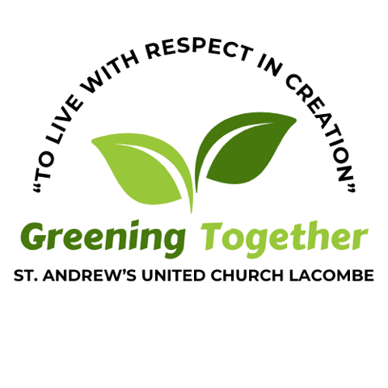
“For you shall go out in joy and be led forth in peace; the mountains and the hills before you shall break forth into singing, and all the trees of the field shall clap their hands.
Isaiah 55:12 (RSV)

We entered the centennial year in high gear, ready to celebrate by planting native trees, with a Memorandum of Understanding signed with Lacombe City Council and a contract with Cynthia Pohl of Living Lands Landscape & Design to guide us through the process from design, ordering, installation, planting and maintenance. The chosen site was the 1.7 acre Woodland Municipal Reserve on Woodland Drive, west of 58 St.
On January 7, Corinne Hansen from Alberta Health Services facilitated a process with the Green Team and friends to define our vision, mission, objectives and values with the resulting statements:

Vision Statement - Create a natural forest ecosystem in Lacombe that inspires and celebrates making a positive environmental impact.

Mission Statement - Our mission is to transform a 1.7-acre grassy municipal reserve into a natural forest ecosystem, planting 100 primarily native species trees, as well as shrubs (some edible fruit bearing), forbs, and grasses

Objectives
- Inform and engage community partners.
- Build and strengthen partnership with City of Lacombe (City Council, Planning and Development, and Parks Departments) to demonstrate a more environmentally friendly way to plant and care for a green space.
- Acquire the funding needed.
- Design our natural forest ecosystem.
- Create volunteer base for installation and for maintenance
- Develop a sustainability plan

On January 15, Cynthia facilitated a teaching & design workshop with about 40 members from the congregation and community at large, including 4 high school students, engaged in learning about native planting and suggesting what to include. An invitation had been sent to about 60 neighbors of the site. Knowledge keeper Linda Ophus was invited to comment on the first draft of the design. Being from Treaty 8, she suggested we seek an elder from Treaty 6 (where we are) to continue our learning. In April, about 30 people enjoyed teachings about the land from Jo-Ann and Jerry Saddleback from Maskwacis, and they smudged the area before work began, as well as singing a song for the big rocks donated by the County of Lacombe.
In March, we received approval from City Council of the design and the name for the space “Woodland Sanctuary. The City has supplied mulch, water, and mowing the paths.

Fundraising
Fundraising to purchase all the plant material and install habitat structures and signage, and pay the landscapers was an extraordinary effort! We were grateful beyond the moon to receive 3 grants totalling $7000, and donations from the congregation and wider community of $21,353 as well as proceeds of $4,000 from the Garage Sale and $3010 from the Legacy Fund. Please see the Book of Trees for details in the social hall and online for all the financial and in-kind donations received. We carried over $ 15,532 from the past two years and entered 2026 with $2,680. As of Dec.31, 2025, $44, 709 was spent on the project.

Volunteers and Planting
Cynthia ordered all the native plant materials from 5 sources, all to be hand-planted to ensure this project would capture more carbon than emit over the long term. The call went out far and wide for volunteers to pick up the trees, etc and plant them on June 6 and 7, and June 20 and 21 in teams of 10 every hour. A huge THANK YOU goes out to some 175 volunteers who worked so hard. They all received a postcard map of the Sanctuary saying “I planted a tree.” Cynthia Pohl and her assistant taught everyone the best way to plant, mulch, water, and install wrap protectors. On planting days, Karen Holmes, helped volunteers to select their plant, find their spot, and complete the job; and later applied Plantskydd to repel deer and rabbits. What a transformation of this grassy area!
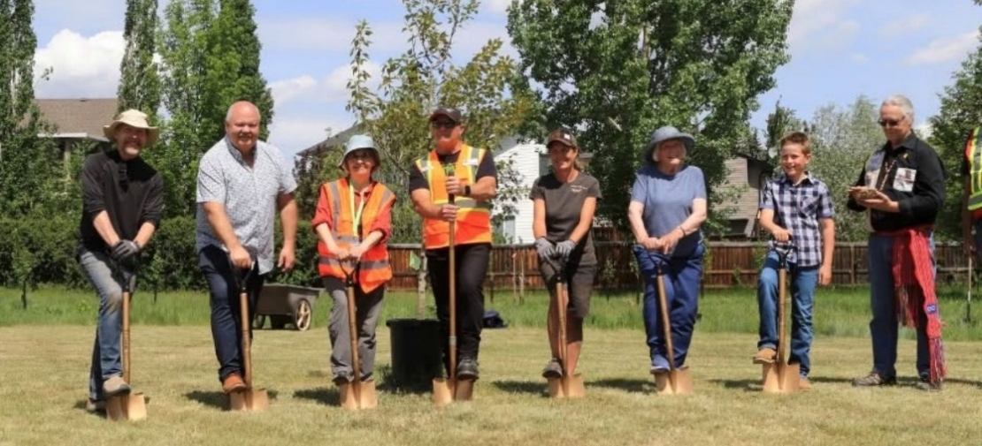
On June 6, we held a ground-breaking ceremony to plant ‘the elder tree’, a balsam poplar in the largest of 3 clearings. Hands on shovels were Rev. Dave Holmes, Mayor Grant Creasy, Green Team rep Doris Thesenvitz, Parks Supervisor Rodney Guilbault, Landscaper Cynthia Pohl, a St. Andrew’s elder Joan Fredeen, and St. Andrew’s youth Kaiden Bruning. Don Fraser smudged with the sweetgrass that Jo-Ann Saddleback had gifted us with.
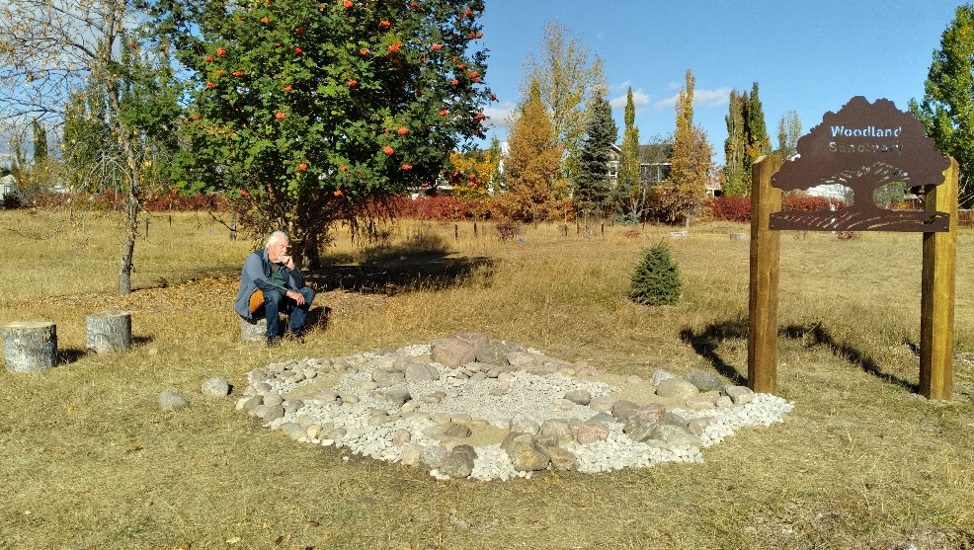
When planting was completed on June 21, we held a dedication ceremony led by Rev. Barbara Lieurance with beautiful violin music provided by Brooklyn Figursky.
An identity sign with the words “Woodland Sanctuary” steel cut within the image of a tree, a story sign, and plant identification signs were installed. In the fall, Living Lands constructed an ephemeral water feature (pictured to the right) for puddling butterflies, bathing birds and providing a moist edge from which bees can safely drink.

Ongoing Community Engagement
In order to fulfill the vision of the Woodland Sanctuary, we are committed to developing ways to invite the community to enjoy, maintain, learn, and be inspired in this ecological landscape. We were pleased to conduct educational tours for the Lacombe Garden Club, and for Burman University: Dr. Dave Delafield’s Outdoor Education class, and Dr. Delano Lewis’ Human Ecology class. Dr. Delafield also led a student team during Burman’s Community Service Day to bring dead trees to “plant” (aka vertical snags) to attract birds such as woodpeckers. We will continue to seek their involvement in education and research, as well as others to plan other events.

Pollinator Garden
The pollinator garden flourished in 2025! Did you see the lupins, the bee balm, the Joe Pye, the
yarrow? So lush! So much Color! Beautiful! Many bees, butterflies and insects visited and
lived in our little garden patch. Thank you to the subcommittee members who tended the garden
throughout the growing season. Thank you, too, to the crew who kept us supplied with
rainwater. And thank you to Bruce Jackson who tends to the composter. Depending on what survives the winter, we may add some new flowers in the spring. A garden: so much to enjoy!

Energy Retrofit Results
In March 2025, being one year since the completion of our Faithful Footprints grant project, we submitted the required energy usage data, and the holdback of $1000 was released. Thanks to Barry Brouwer for continuing to enter our energy usage data into the Energy Star Portfolio Manager. We have decreased our metric tons of greenhouse gas emissions by 30%; we have a long way to go to see an 80% reduction.
We used 2622 kWh (10.7%) more electricity in 2025 than in 2024 – we believe this is because of much higher building occupancy. We have reduced our 2025 natural gas consumption compared to 2024 by 6% through much better insulation and windows.

Green tips, offset travel
For much of the year, we continued to encourage individuals to take personal climate positive and environmental stewardship actions through “green tips” in the weekly bulletin. This year the United Church of Canada initiated an opportunity to offset your air travel carbon footprint by supporting a Canadian Foodgrains project in Kenya that is addressing climate change. You can make your donation here.
There are so many environmental concerns we could be learning more about and acting. Webinars and newsletters from ecumenical organizations like “For the Love of Creation” and KAIROS and the Advent resource “All Creation Waits” have enriched our conversations and revived our spirits. A strategic planning session scheduled for January 17, 2026 will help us discern where to focus our efforts for the next 2-3 years.

Membership
As often happens when big projects are completed, people are tired and seek a change in their commitments. So we offer profound thanks to Donnie Tafts, Babette Dorn, Bob Winchell, Barbara Lieurance, and Wendy Jeynes for their many hours of work and enthusiastic support. At the same time, we are delighted to welcome new members Elco and Joanne Vandergrift and Pat Halberg who helped plant and are now keen to deepen and embolden our creation care into the future. More land and water stewards are welcome to come and join us!

Greening Together,

Dianna McLeod and Cecile Fausak, co-chairs

Bruce Jackson, Elco Vandergrift, Joanne Vandergrift, Pat Halberg, Doris Thesenvitz (taking a break)

MINISTRY & PERSONNEL TEAM

The M & P Team of St. Andrew’s is a team of trust and confidentiality that provides support, assessment of and consultation with all ministry personnel and non-ministry staff of the church. Comprised of individuals from the congregation appointed to 3-year terms, the team provides a liaison between and among the congregation and the ministers and other staff of St. Andrew’s. As an advisory body, the team makes recommendations to the church board on ministry and personnel matters. The M & P Team is represented on the Church Board. Our membership for 2025 was: Sandra Smith, Ron Gish, Bob Jenkins, and Barry Brouwer.

Janitorial, Custodial & Grounds Keeping – Jill Hair continues to provide (since September 2020), excellent care of our building, in the janitorial position. The security/custodial contract is with Diane Hayduk, who has served a vital role since 2018! Thank you to Norm Start for the excellent lawn care in 2025, and to Hans Haefliger for maintaining the beautiful flowerbeds throughout the spring, summer, and fall. The snow removal contract with I Care Lawn Service (Terry Souveny), will continue for the first half of 2026. Terry’s contract with us began in December 2021 and Terry is retiring from this role after the 2025/2026 winter season. We are very fortunate to have so many dedicated contractors and volunteers filling these essential roles!

Staff Liaison - Individual committee members endeavor to maintain regular and open communication with individual members of the Church staff, and these liaisons include:

Committee Member | Staff/Contract Position
Bob Jenkins | Communications Coordinator – Jana Figursky  Bookkeeper - Shannon Epp
Bob Jenkins | Building Janitor – Jill Hair
Ron Gish | Full-time Ministry Position – Rev. Dave Holmes
Sandra Smith | 35% Ministry Position – Rev. Barbara Lieurance
Barry Brouwer | Children’s Program Coordinator -  Brenna Trimble (beginning in 2026)
Sandra Smith | Worship Positions (Choir Director & Pianist)  Choir Director - Leanne Oslund  Pianist - Nicole Bartolay
Sandra Smith | Honorary Associate Minister – Rev. Bob Settle
Sandra Smith | Building Security/Custodian – Diane Hayduk
Barry Brouwer | Snow Removal - Terry Souveny
Barry Brouwer | Ministry & Personnel Committee Chair

Bob Jenkins began a three-year term in January 2025. Sandra Smith has served four consecutive 3-year terms on this team (since 2013!) and is resigning from the team this year. Thank you, Sandra, for your dedication and support for so many years! We need a volunteer to fill the vacancy created. I have served as chair since 2016. If the Church Board nominating committee is unable to find new volunteers to join the team, Barry and Ron are willing to serve for 2026. Ron has represented Rev. Dave since he arrived five years ago. Members of the Congregation wanting to comment regarding an individual staff member or position are encouraged to contact these Committee Members.
Submitted by Barry Brouwer, Chair

OUTREACH TEAM

Central Alberta Foodgrains Growing Project

We completed Year 30 in 2025 and are pleased to report we sent $57,000.00 to the Canadian Foodgrains Bank (CFB) in Winnipeg in late December.

In 2026, we have secured 140 acres of land to grow a crop just west of the Blackfalds overpass off Highway 2. Heading west on Aspelund Road, proceed to Range Road 27-5, and then turn north for ½ mile. The field is on the east side of the road. Legal description is NW 29-39-27 W4th. This is the parcel of land we had for the first three years of the project starting in1996.
In the 30 years of our growing project, we have forwarded just over $2,000,000.00 from crop sales and cash donations, to the Canadian Foodgrains Bank to help hungry people internationally. The Canadian Government matches our contribution at a ratio of 4:1.
Our success has been achieved with wonderful support from Lacombe County farmers, agri-businesses, local businesses, churches, donors, supporters and the media.

In those years, land has been secured in all different parts of Lacombe County to grow a crop. Sometimes the land has been donated for use by the landowner, other times the committee has paid cash rent.

The United Church of Canada is one of 15 church partners that comprises the CFB that was created in 1983. Last year, the charity provided assistance to 1,176,111 people in 37 countries. Growing projects supporting CFB are located throughout Alberta and other parts of Canada. Our Central Alberta project is one of the oldest in Canada.

Cash donations are always welcome, to assist with items such as crop insurance, and crop inputs that are not donated. These donations are eligible for an official tax receipt, as the Canadian Foodgrains Bank is a registered Canadian charity.

If you wish to donate, or want more information on the local growing project, please contact Doug Maas at 403 318-5733. Cheque donations should be made payable to the CENTRAL ALBERTA FOODGRAINS PROJECT.

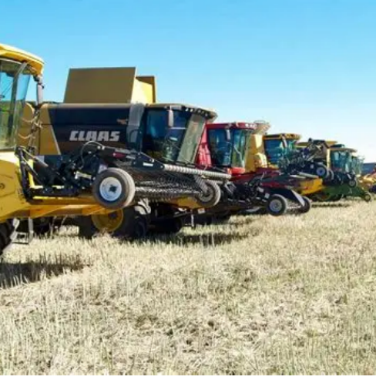
Thank you to our Community of Faith for all the compassionate support we have received since 1996. A true Christian response to hunger.


OUTREACH TEAM

Lacombe Food Bank

Thank you, people of St Andrew’s, for continuing to support the Lacombe Food Bank. The Director, Brenda Stoodley, is always so thankful when I bring the donations from our church. She counts St Andrews as one of the most reliable and generous supporters throughout the year. In 2025, donations from our church were as follows: January - 29.8 lbs. February - 7.6 lbs. March - 17.2 lbs. May 18.2 lbs. June 6.6 lbs plus $75. July/ August - 17 lbs. October (Messy Church) - 147.6 lbs. November/December (Includes White Gift Sunday) 212 lbs plus $355. Our grand total for the year was 456 lbs of food and $ in cash.

Please remember the Food Bank when you are doing your grocery shopping. You may bring donations to the church on any Sunday, and at the end of the month they will be taken to the Food Bank to be weighed and documented as coming from St Andrews. There is always a need. Use of the Food Bank has increased over the past few years, and there are often big, empty spaces on the shelves. Our contributions are greatly appreciated.

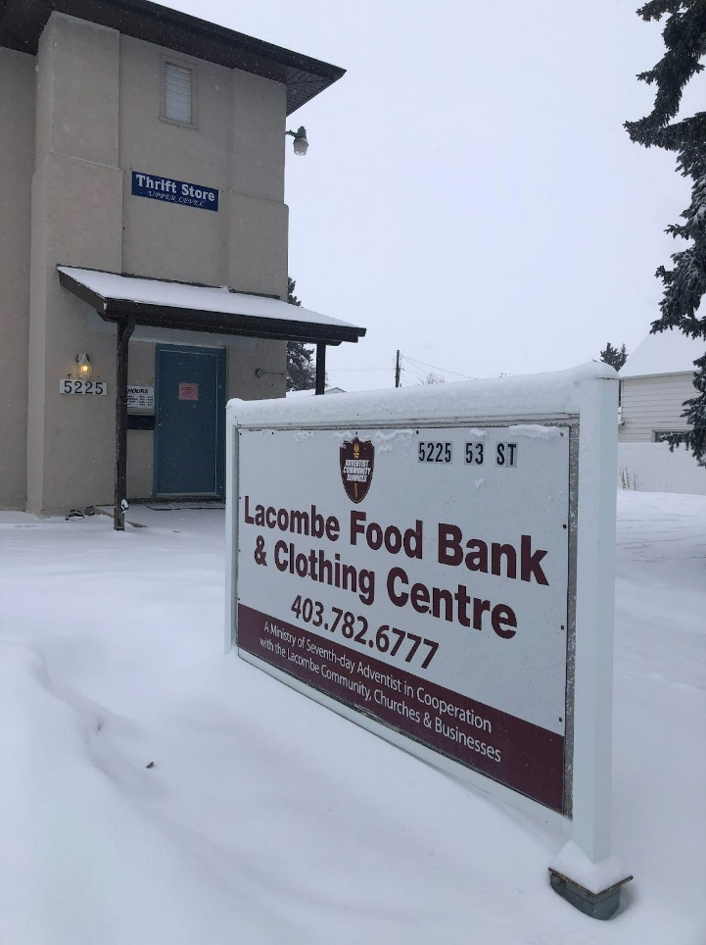
Submitted by Dianna MacLeod
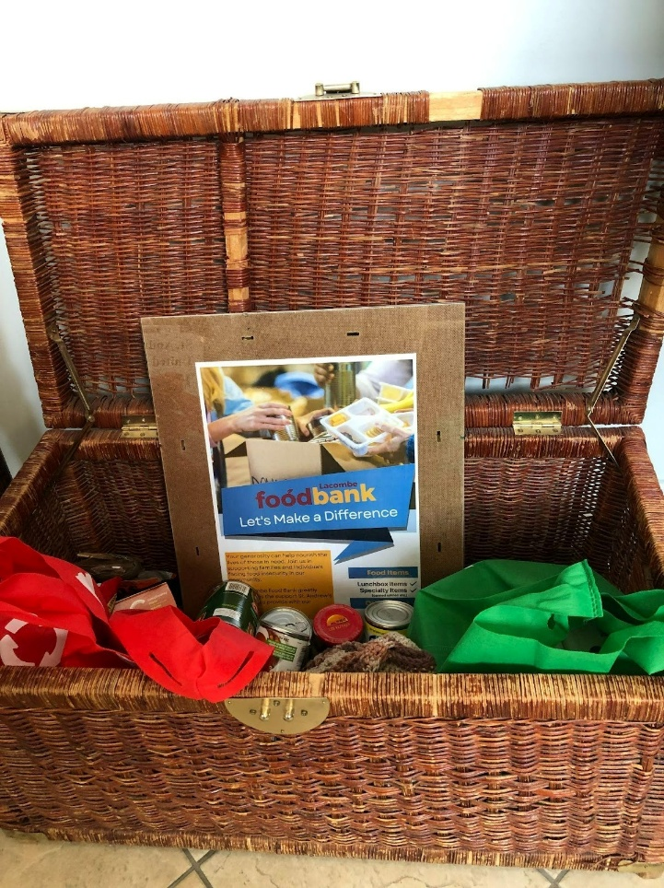

PROPERTY TEAM

At the Annual General Meeting in April of 2025, I took over the reins of Property Chair from the very capable hands of Gary Macdonald.

Gary oversaw several major projects in 2024. This year was a quiet one as far as major projects go. However, the board delegated to the A & M Team two items affecting property.
The first is to present a plan for the use of the St. Andrew’s building that fits in with our values and missional priorities. Members of this team are Greg Pallister, Gary Macdonld, Darryl Langille, Donna and Ron Gish, Dave Holmes, and Lawrence Hrycan.
The second is to present a plan to improve the accessibility of our building with particular emphasis on the physical accessibility to the sanctuary. The members of this team are Rick Schmidt, Bryant Burnard, Dave Hnatiuk, Darryl Langille, Dave Holmes, and Lawrence Hrycan.
The congregation will have regular updates as these teams continue in 2026.
There are many people who play an active role in the maintenance of the church and deserve a huge thanks:

- Greg Pallister who has taken on the responsibility to see that our elevator is regularly inspected and in working order. Greg is also involved in many other things dealing with property. Bob King continues to use his skills and magic to keep things working in the church. Dennis Ethier is often seen with Bob doing repairs around the church.
- Norm Start maintained our lawn for many years. Bill Conley took over from Norm in August. A shout out to Hans and the gardening team for making our grounds look beautiful and inviting and to the Green Team who work hand in hand with Property to ensure that the church is being as efficient as possible.
- The UCW continue to take care of the kitchen both physically and financially, as well as contributing to other needs as they arise.
- We are fortunate to have a team of Jill Hair, Diane Hayduk, and Terry Souveny who take care of our property inside and outside. You may have seen Jill as she is often putting on that last coat of paint to freshen things up.
- Jana Figursky and Shannon Epp ensure that annual inspection certificates for the kitchen, elevator, fire and safety, and insurance are completed, posted, and paid for.
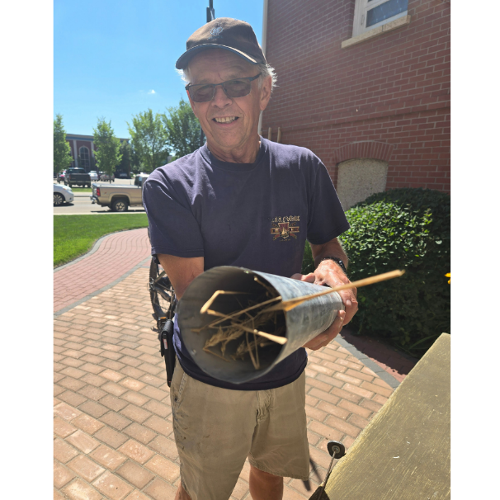
Also, thank you goes to Gary Macdonald who continues to mentor me in the ways of providing the best care for our church and property.

And finally, Thank You to the congregation who support St. Andrew’s and their goals and help provide the best environment for everyone.

UCW 1

In December we welcomed two new members, bringing our active total to 19. We host two planning meetings each year and in between we get together on Thursday mornings for coffee at Marion’s Eatery. Members also gather for lunch most months at various restaurants around Lacombe and the occasional movie night. In December we enjoyed a lovely Christmas celebration at Leto’s.

Our Unit is responsible for cleaning the kitchen top to bottom in June. We supply all of the Fair Trade coffee for the kitchen, and order kitchen supplies as needed.

In October members baked a total of 121 large regular and gluten-free Christmas cakes , and 97 small cakes both regular and gluten-free.

Our major fundraisers are the Christmas cakes and Annual Bottle Drive. With the proceeds from these two fundraisers we were able to donate $400. each to Kasota East Camp, Junior High Breakfast Program, Lacombe Composite High Food Cart, United Church UCW Healing Fund, Broom Tree Foundation, Red Deer Outreach Centre, and St. Andrew’s Benevolent Fund.

Unit 1 serves coffee and refreshments following the service on the third Sunday of each month, and provides a birthday cake for all of the birthdays that month. On December 21st we hosted a Christmas Tea for the congregation.

Respectively submitted
Jane Wilkinson

UCW 2

Unit 2 currently has 16 active members, which includes one new member this year. We meet once a month, the 3rd Tuesday, at 2:00 p.m. in the parlor. We normally have a short business meeting and then have time for coffee and a visit – a great social time. Two of our members moved this year to be closer to family.

In the past year, we catered 5 funeral lunches. As well as our regular Coffee Sundays, various members cooked and helped with Messy Church, helped with the Garage Sale and the ‘Lift Someone into the Light” Advent activity. Once again several of us attended the Women’s Conference in Rimbey in April and the Christmas Centrepiece workshop at the Kassies farm in December. Several members helped deliver Meals on Wheels during the summer. We also cleaned the kitchen and sorted our UCW storage room in January.

In June, we held a BBQ for our Unit and their significant others. We took this opportunity to acknowledge Ev and Norm Start. They have been an integral part of our church and our UCW Unit. We wish them all the best in this new road they travel. During the summer, Florence Douglas made the decision to move to Calgary to be closer to her family. A special afternoon tea was held in her honor as she begins this new chapter in her life.

Our donations this year included the FCSS and their various projects, trees for the Woodland Sanctuary Project, sponsored a camper at Camp Kasota, Foodgrains Project, The Broom Tree, J.J. Collett and donated funds towards the Church coffee. We enjoyed two lunches in lieu of meetings in May and December.

For the 2nd year, along with Unit 1, we hosted a Robbie Burns Day luncheon for the congregation. It was a great event and enjoyed by everyone. |A freewill offering was taken and split between the two Units, the money going towards various projects, both within the Church and in the Community.

Respectfully submitted, on behalf of Unit 2
Susan Hrycan

UCW PURPOSE: To unite all women of the congregation for the total mission of the Church and to provide a medium through which they may express their loyalty and devotion to Jesus Christ in Christian witness, study, fellowship, and service.

WORSHIP TEAM

The Worship Team is grateful for another full and faithful year of gathering, praising, listening, and responding together as a community of faith. Week after week, worship at our church continues to be shaped by dedication, creativity, and a deep sense of shared purpose—and that is entirely thanks to the many people who give their time and gifts so generously.

First and foremost, we offer a heartfelt thank you to all the volunteers who contribute to worship every Sunday. To all our musicians, choir, Leanne and Nicole, our greeters, readers, Jana for the bulletin and visual presentation, and the ever-faithful audio/visual team. Each role—seen and unseen—helps create worship that is welcoming, meaningful, and alive. Your consistency and care ensure that worship flows smoothly and that all who enter feel invited into something sacred.

The Worship Committee this year included Sarina King, Gail Wilson, Dave Holmes, and Darryl Langille. Together, the team shared responsibility for the many moving parts that make worship possible. Our areas of focus included planning and supporting Sunday worship, preparing and serving communion, assisting in organizing special services throughout the church year, and overseeing sanctuary setup and decorations. Whether it was a seasonal change, a special liturgical moment, or a simple Sunday morning, attention was given to creating space that supports reflection, joy, and connection.

A key—and increasingly energizing—part of our work has been serving as a sounding board for Dave in worship planning. This role has grown beyond logistics into a place of active collaboration. The committee has leaned into encouraging creativity and innovation in our worship life: exploring themes, trying new ideas, asking "what if?", and supporting thoughtful risks that help worship remain fresh and relevant while grounded in our faith tradition. These conversations have been a highlight of the year and a reminder that worship planning is both holy work and joyful work.

Another ongoing responsibility has been organizing volunteers, ensuring that readers, greeters, musicians, and support teams are scheduled and supported. This behind-the-scenes coordination helps Sunday mornings unfold with calm rather than chaos—and allows everyone to serve with confidence.

As we look back on the year, we are thankful for a congregation that worships with openness and generosity of spirit. It is a privilege to help shape this shared work, and we look forward with anticipation to what God will continue to create among us in the year ahead.

WORSHIP TEAM

Audio-Visual Team

St. Andrew’s regularly live-streams the Sunday morning Worship service. In addition, we have also live-streamed funerals and weddings. The team responsible for the live streaming consists of Brielle Figursky, Tristan Maloney, Lark Beauchesne, Laura Warkentin and Lawrence Hrycan. Jana Figursky prepares the PowerPoint that makes the AV Team, and the Ministry Team look good!
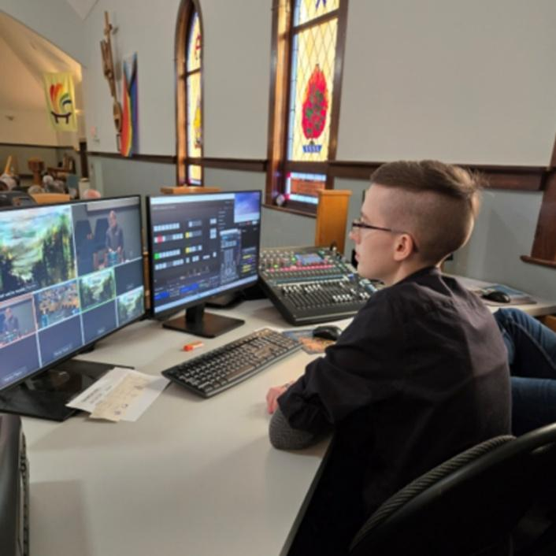
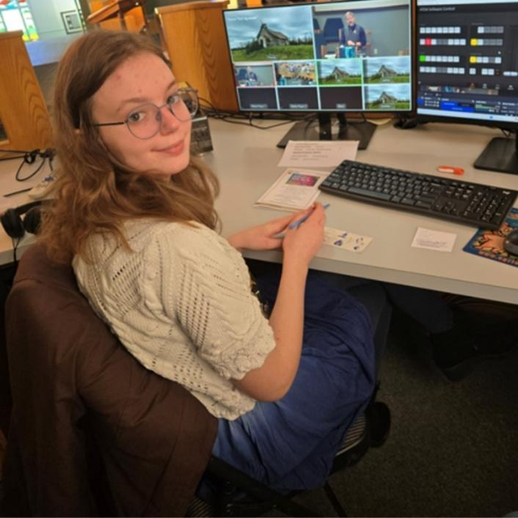
The Audio-Visual Team keeps a record of how many people watch online. Some people watch as the service is live, while others choose another time that works better for them. Included here are the statistics kept for the month of December 2025. The chart shows how many are watching the service live, and then how many views there are up to a couple of weeks later – in this case – as of February 22, 2026.
DATE | # IN CHURCH | ON-LINE | TOTAL VIEWS ONLINE  (as of Jan. 11)
Dec. 7 | 112 | 28 | 61
Dec. 14 | 83 | 34 | 92
Dec. 21 Cantata | 144 | 41 | 119
Dec. 24, 7 p.m. | 125 | 20 | 48
Dec. 24, 9 p.m. | 61 | 10 | 44
Dec. 28 | 43 | 43 | 83
Jan. 4 | 78 | 36 | 92
Jan. 11 | 108 | 32 | 79
January 18 | 92 | 52 | 129
Jan. 25 | 85 | 47 | 105
Feb. 1 | 79 | 55 | 132
Feb. 8 | 92 | 34 | 63
Feb. 15 | 84 | 30 | 101
Feb. 22 | 85 | 29 | 79

While people watch online, they often say hello from Calgary, Victoria, Edmonton, Arizona, Toronto, Holland, and anywhere else they might be. It is interesting to follow the chats as the Sunday morning service moves along. Often, at the end of the service, the Audio-Visual Team will put the chats on the screen in the Sanctuary so people can see the comments.
Thank you to those who watch online for sending positive comments to the Audio-Visual Team. It is nice to know that people are enjoying this service. We are always open to suggestions on how to make the service more enjoyable. Feel free to let us know.

CHURCH STATISTICS FOR 2025

Marriages 2025 (0)

Funerals 2025 (11)

George Gaudin
Jonathan Antsey
Brian Winslow
William Atkinson
Claranne Dixon
Deborah O’Connell
Herbert Cookson
Joy Thompson
Barbara Stevens
Nellie Wells
Robert Reiter

Baptisms 2025 (2)

Laura Warkentin
Lorna L’Heureux

Confirmations 2025 (0)

Transfers 2025 (0)

