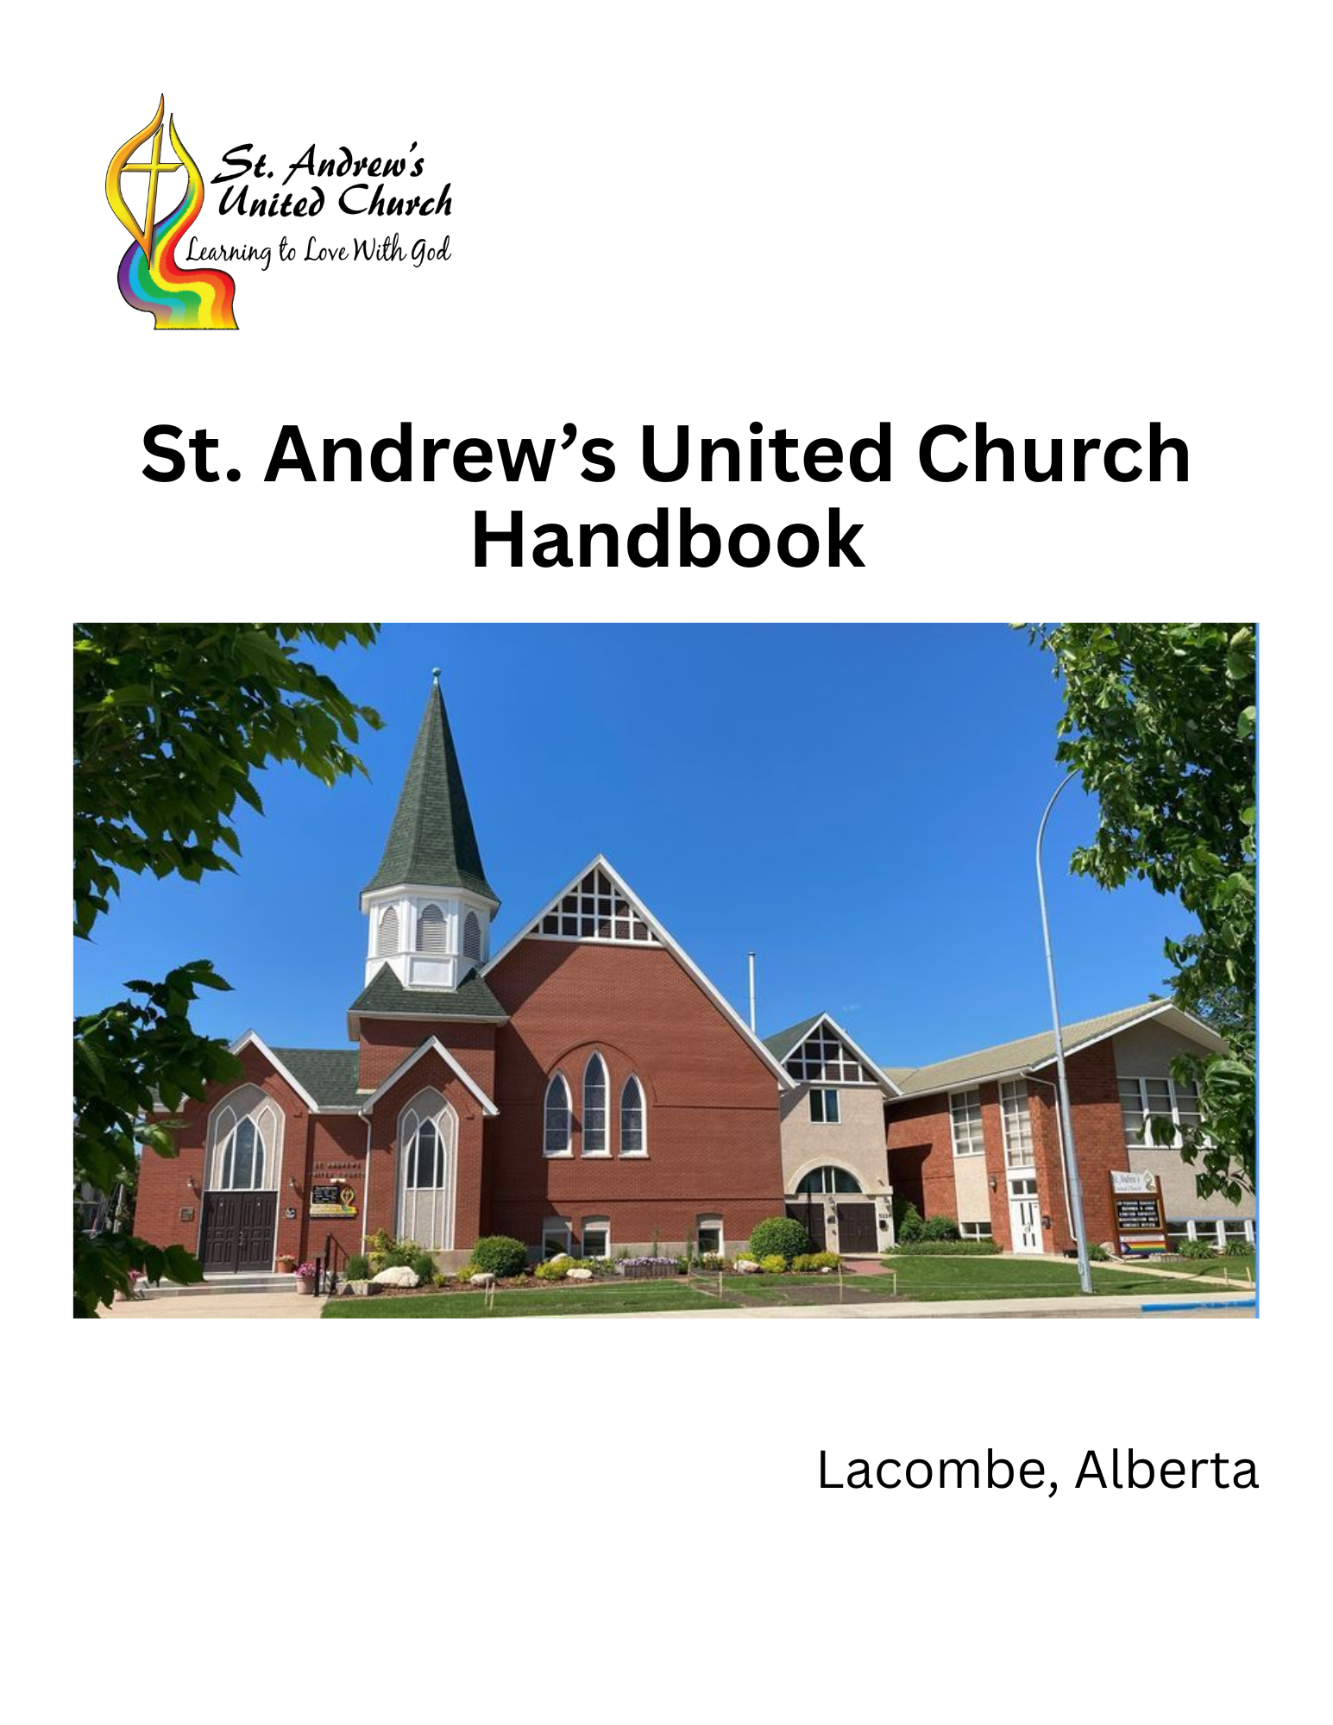
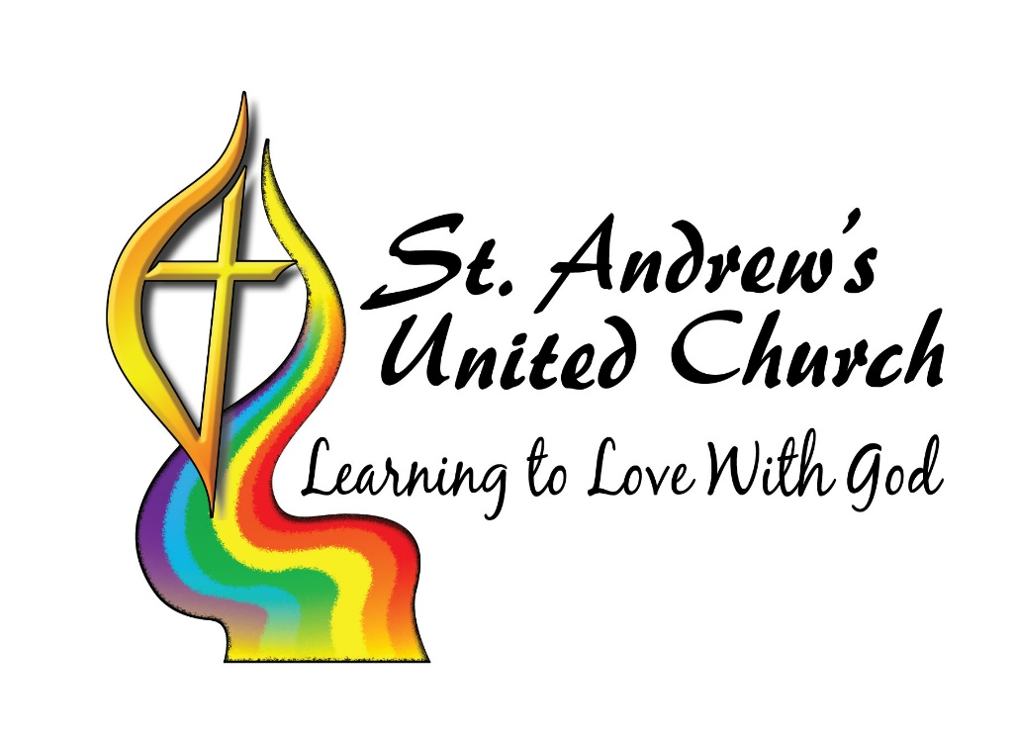
MISSION
St. Andrew’s United Church strives to be a caring Christian community that nurtures love of God and neighbour through worship, fellowship, learning, and service.

Contents
Mission/Vision/Values/Philosophy/Outcomes 4
Mission statement 4
Slogan/logo 4
Values 4
Vision: missional priorities 5
Board 7
Regional Representation at Board meetings 8
Roles and Responsibilities of Board Members 9
Expectations of Board Members 9
Removal of Board Members 10
Board Chair 11
Board Secretary 11
Regional Representative 11
Ministry and Personnel Committee 12
Hiring Committee 12
Board of Trustees 12
Trustees 12
Nominating Committee 13
Policy Committee 13
DELEGATION AND ACCOUNTABILITY 13
Delegation of Authority 13
Accountability 14
ADMINISTRATION AND MINISTRY TEAM 14
ACTION TEAMS 15
Christian Development 16
Congregational Life 17
Finance and Stewardship 18
Ministry and Personnel 19
Outreach 20
Property 20
Worship 21
United Church Women (UCW) 23
Staffing 23

Mission/Vision/Values/Philosophy/Outcomes

Mission statement
St. Andrew’s United Church strives to be a caring Christian Community that nurtures love of God and neighbour through worship, fellowship, learning, and service.

Slogan/logo
Learning to love with God

Values
AFFIRMING: St. Andrew’s is committed to being a church that accepts and affirms people in all their diversity. This includes diversity in sexual orientation and gender identity/expression, as well as theological and religious diversity, age diversity, economic status, race, health, etc. We are committed to accepting people in their brokenness. This value is based in the belief that God loves all of us without condition and without exception. God’s love is the beginning of our faith journey, as much as its end.
INTEGRITY: St. Andrew’s is committed to being a church in which faith is a practice, in which our beliefs issue forth in action. “Practice” also implies that faith is a process of learning and growth in which we never completely “arrive.”
TRANSFORMATION: St. Andrew’s is committed to being a church in which we, ourselves, are being transformed in Christ – in which we are becoming whole, finding healing, learning, exploring, finding depth, both as individuals and as a community.
PROGRESSIVE THEOLOGY: St. Andrew’s is committed to a faith that welcomes questions, doubts, and scientific insight. This is based in a belief that Christianity is not static but progressive – that the faith itself, and our understanding of it, grows, matures, evolves through history and through our own lives.
RESPECT: St. Andrew’s is committed to living with respect:
- In our relationship with the earth, God’s creation
- In our relationship with First Nations, Metis, and people of other faiths and none
- In our relationship with one another, and with our community.
- In particular, towards those who are poor, in need, infirm, oppressed or left out by the powers-that-be in society
This value calls us to an anti-racist practice, as well as a ministry that seeks justice and compassion in the structures of our society.

SUSTAINABILITY: St. Andrew’s is committed to sustainability, in the midst of a culture that is largely unsustainable.
- We are committed to sustainable church life – the ministry of this church should be life-giving, not life-draining.
- We are committed to doing what we can today to support this church’s ministry into the future.
- We are committed to an economic and environmental lifestyle that is just, sustainable and even restorative.

COMPASSION: St. Andrew’s is committed to non-violence: to resolving conflict with respect and care, to respect and civility in political matters, to kindness and fairness in all our dealings. Our struggle is not against people who may disagree with us, or cause us harm: our struggle is with the spiritual forces of evil and harm in the world. Jesus calls us to love even our enemies.
JOY: St. Andrew’s is committed to being a church of joy and gratitude. In spite of any struggle, God is always present with love, and Creation is a world of wonders and grace, infused with God in every place.
PARTNERSHIP: St. Andrew’s is committed to, and believes in, the value of community partnerships. We are not alone in our ministry! The Spirit works through others as well, and we strive to work in partnership – with other churches, other faiths, community organizations.

Vision: missional priorities
In the consultations we heard people value St. Andrew’s as a spiritual home – a community that welcomes all into a loving connection both with God and with the community of faith itself. We want to be welcomed in our diversity, and even in our brokenness and struggle (and we want others similarly welcomed), we want to find genuine, deep, and healthy relationships/friendships here. Openness and intimacy is actually an incredibly difficult combination. It requires an openness to those who are genuinely different, and those who need healing – usually an uncomfortable thing. It also requires community structures and supports that allow sometimes-unhealthy people to have healthy relationships. At the very least, we will need to have practices and forms to constantly build relationships, trust and support, and practices and skills in “arguing for the sake of heaven” (constructive and community-building conflict). One missional priority is to nurture St. Andrew’s as a healthy, welcoming, affirming spiritual community.
In the consultations we heard people valuing St. Andrew’s as a place of spiritual growth. There are several aspects to this: people seek and have found healing in this community (in a variety of ways), people look for a particular theological “fit” (people here tend to take a “progressive” stance with respect to religion and theology, meaning that we understand faith and belief to be something that evolves, changes, develops over time. Our Affirming stance, as well as our work in Living into Right Relations, environmental action and awareness, and our disengaging from colonial theology, are examples of this). Our current documents acknowledge that we are seeking our own transformation here, and not simply trying to bring others into the fold. One missional priority is to nurture St. Andrew’s as a community of spiritual practice, growth, healing, and transformation.
A third thing that seemed clear in our consultations was that people valued St. Andrew’s as a community of action. This comes in two ways: people in this church are active, participating in the work of the church in many ways. There are very few “passengers” in this congregation, and of those not currently involved in ministry or leadership, most are elderly and have a long history of involvement and leadership in their more active years! But the people of St. Andrew’s are not only involved in church – our discipleship leads us as much into community involvement as it does to church involvement. Service to, and leadership in, ministries and organizations from schools to sports to arts to social services is also a part of our mission as a church and as Christians. One missional priority is to nurture St. Andrew’s (and its people) in service to the community – encouraging involvement, training for leadership, and helping to organize (partnering with) the wider community.
Finally, there was a good deal of awareness, and concern, about the trends both in society and in the United Church nationally. Church is difficult these days, especially in the United Church, and there was much concern around the sustainability of this congregation. How might we nurture congregational growth? What can we do to plan for the continuation of this congregation’s ministry and health? One missional priority is to nurture the institutional health of St. Andrew’s, such that we can be confident of its sustainability into the foreseeable future.
There are some key issues around which there appears to be energy right now, within the church community. These are the issues around which our ministry is likely to gather:
- Environmental sustainability and climate change (This is perhaps the single top priority issue, connecting as it does issues around lifestyle, societal anxiety, economics, and spirituality)
- Affirming ministry (most of the newer people in this church affiliate with us primarily or secondarily because of our affirming stance. There is also increasing societal pressure on LGBTQ+ persons here in Alberta.)
- Economics: This is a “dual” issue – on the one hand, our consumer capitalist economy is negatively affecting us in several ways generally, from environment to social isolation and general unhappiness. On the other hand, the economic disparity of our system has left many – including here in Lacombe – unable to make ends meet. We seek to both challenge the system and to support those in need.
- Division and peace: We are aware of the increasing polarization of our society – especially politically – and of the violence just under the surface. We feel a call to peacemaking and bridge-building.

Board

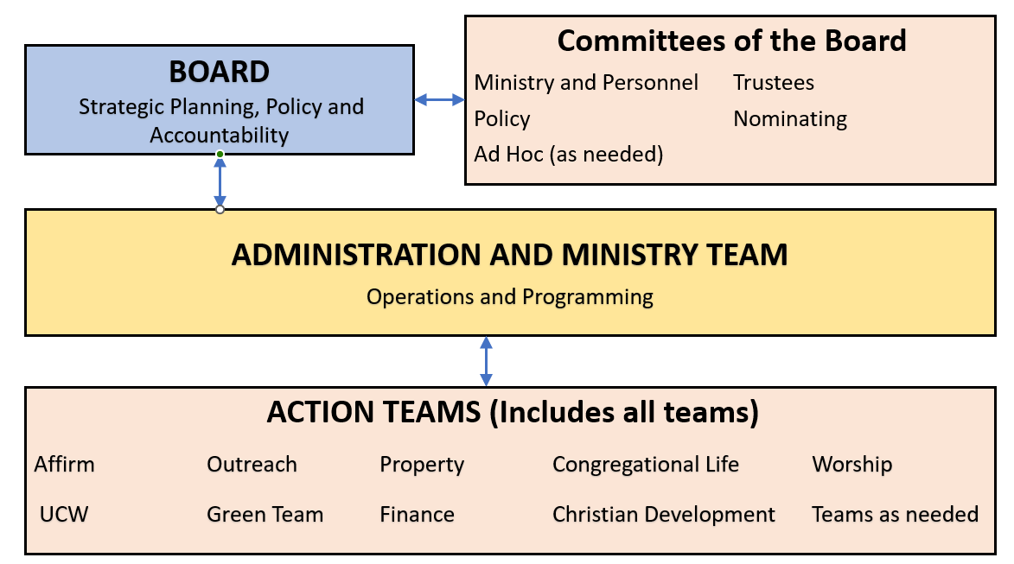
The St. Andrew’s Church Board (board) leads the congregation in ensuring that it understands and carries out its Mission as a Community of Faith in Jesus Christ.
The board consists of the members below who will be elected at the Annual Congregational Meeting. Each member may serve a maximum of 2 three-year terms. The board chair is elected annually for a 1-year term and may serve up to three terms consecutively. A board member or chair must have at least one year not served before they may serve again. The board chair must be a member of St. Andrew’s Church. Other members of the board are to be a member or adherent of St. Andrews Church.
The board consists of 9 elected members and the called ministers as listed below.
- Chair
- Board Secretary
- Treasurer
- Ministry and Personnel Committee Representative
- Chair of Finance Committee
- Chair of Property Committee
- Chinook Winds United Church Regional Representative (Regional Representative)
- Member at large (2 positions)
- Called Ministers

All board members shall have voting power. However, the Board Chair shall only exercise their vote at the board level in the event of a tie.
Quorum for the board shall consist of five of the nine elected members and one called minister. In the event that a called minister is unable to be present, an appointed regional minister representative may fill in. A quorum must be present for any vote or decision to occur, however a meeting may proceed as an information session, but no voting or decision may be made.
Board members must recuse themselves from any conflicts of interest. See Conflict of Interest Policy.
Only board members are voted in at the Annual Congregational Meeting. Action team chairs and members will be determined at the Administration and Ministry Team level.
The following positions are nominated and elected by the membership as a whole at the Annual Congregational Meeting.
- Chair
- Board Secretary
- Regional Representative (2 positions)
- Member at Large (2 positions)
- Chair of the Finance Committee
- Chair of the Property Committee

The following positions are appointed by the finance committee and the board and the congregation is informed at the Annual Congregational Meeting.
- Treasurer - Finance Committee
- Ministry and Personnel Committee Chair and committee members - Board

Regional Representation at Board meetings
Up to two regional representatives may be elected to represent the congregation at the regional level. However, only one regional representative will sit on the board at any given time, with the representatives determining amongst themselves who will serve. If the primary representative is unable to attend a board meeting, the alternate representative may fill in.

Roles and Responsibilities of Board Members
Reference: The Manual of The United Church of Canada, (current edition)
The board is responsible for the items listed below.
Strategic Direction
- Development of Mission, Vision and Value statements
- Long term Vision for the ministry – 3 to 5 years
- Short term Vision for the ministry – annual goals
Oversight of the local administration
- Finances
- Governance
Staff oversight and program
- Hiring, firing and discipline of lay staff
- Advocacy for the lay and ministry staff through the Ministry and Personnel Committee
- Oversight and Discipline of Ministry Personnel through the United Church Office of Vocation
Delegation
- Delegation of goal implementation to Administration and Ministry team
Policy
- Policy decisions
- Policy review and update
Engagement with the congregation
- Use different approaches of engagement to ensure that the congregation has a voice

Expectations of Board Members
The board is the body empowered by the congregation to have oversight over the congregation’s ministry and affairs. The board is responsible for ongoing congregational engagement as part of their visioning process. After delegating the administrative operations and ministries of the church to the Administration and Ministry Team and action teams, the primary work of the board is oversight, and attention to the mission and vision of the church. As such, it is important for the board to provide both leadership in these things, and embody the vision and values of the congregation in how they do these things.
The following are expectations of all board members, expressed as a covenant to be signed by each board member at the first meeting of each new board.
Board members are expected to the best of their abilities to:
Prepare for board meetings: Read pre-meeting packages before the meeting and seek additional information as needed to actively participate in board business.
Attend all board meetings: If you are unable to attend, inform the board chair as soon as possible.
Participate in board meetings: Listen with curiosity, speak with honesty and respect, and always keep in mind the congregation’s mission and values.
Contribute to board activities: Support board initiatives outside of meetings. Participate in events, volunteer opportunities, and build relationships with church members.
Treat one another with respect: Abide by the congregation’s values, follow conflict resolution procedures, and uphold our covenant of care for one another.
Maintain confidentiality: Do not discuss board matters or opinions shared by other members of the board outside of meetings. Honor confidentiality agreements made regarding specific matters and address concerns with the board chair as needed.
Respect board decisions: Speak respectfully of board decisions and the boards authority to make final decisions, even when individual members may respectfully disagree.
Conflict of Interest: Abide by the Conflict of Interest policy and promptly disclose any conflicts to the board or chair.
Personal spiritual growth: Attend to your own spiritual growth and well-being, both as a board member and in your personal lives.
Scheduling of board meetings will be determined by the board and all members are expected to attend a board retreat (1 to 2 days) once a year.

Removal of Board Members
A Board member may be removed before the end of their term by a vote of the board for any of the following reasons.
Resignation: Formal voluntary departure from the board.
Relocation: Moving away from the area, making continued service impractical.
Leaving the United Church Denomination: Ceasing to be a member of the church.
Excessive absence: Frequent or prolonged absent from board meeting without valid reason, including, but not limited to, three consecutive absences.
Exhibiting unsuitable behavior: Engaging in actions such as violating the code of conduct, being disruptive, not abiding by board expectations or failing to fulfill board duties.
Other reasons: Any other reasons deemed necessary by the board for the well-being of the congregation and its governance.

Board Chair
The chair provides leadership to the church board, ensuring that issues are discussed thoroughly and fairly and that disagreements are dealt with openly and respectfully.
Proficiencies
- Ability to conduct meetings using Bourinot’s Rules of Order.
- Commitment to the success of the church’s vision
- Leadership skills: organization, communication, listening, delegation, negotiation and facilitation.
- Energetic and personable.
- Ability to work cooperatively with others.
- Working knowledge of church policies and procedures.
- Preferably has completed two years on the board prior to assuming the Chair position

Roles and responsibilities
- Calls, attends, and chairs regular church board meetings.
- Calls, attends, and chairs special board meetings as needed.
- In collaboration with the board secretary, provides for distribution a written agenda.
- Chairs all congregation of the whole meetings.
- Chairs all meetings in according to Bourinot’s Rules of Order
- Prepares the agenda for annual congregational meeting.
- Trains new board members and offers guidance as necessary.
- Writes and submits annual board report to office by January 31 for the prior year ending December 31.

Board Secretary
The Board secretary will be responsible for the following items.
- Take meeting minutes
- Provide minutes to the church office for distribution, and recordkeeping
- In collaboration with the board chair, provide a written agenda for distribution.
- Communicate board messages to the congregation with the support of the Communications Coordinator
- Manage correspondence to the board

Regional Representative
Chinook Winds Regional Representative communicates information from the Region to the Board and from the Board to the Region.
COMMITTEES OF THE BOARD

Ministry and Personnel Committee
References: Ministry and Personnel Committees: Policy, Procedures, Practices Handbook (current edition).
The Ministry and Personnel Committee is a committee of trust and confidentiality that has three distinct roles: the consultative and supportive role, the healthy relationships role, and the supervisory role. These roles are helpful lenses through which to see the best practices, which can be used to fulfill the Ministry and Personnel Committee’s responsibilities, according to each policy statement within the manual.

Hiring Committee
The hiring committee is an ad hoc committee and will be formed as required for the hiring of lay staff and be tailored to suit the needs for each particular hire. It will have at least one representative from the Ministry and Personnel Committee.

Board of Trustees
The Trustees for St. Andrew’s United Church consists of the following board members.
- The Chair of the Finance Committee
- The Chair of the Property Committee
- The Chair of St. Andrew’s Board
- Chinook Winds United Church Region Representative
- St. Andrew’s pro tempore called minister
The trustees are confirmed at the Annual Congregational Meeting.

Trustees
The Trustees for St. Andrew’s United Church consists of a member of the Finance Committee, the Property Committee, Chair of the Official Board, the Chinook Winds Region Representative, and a minister. The trustees are voted on at the Annual General meeting.
RESPONSIBILITIES – All lands, premises, Real Property and Personal Property held or acquired in trust for or for the use of a congregation are to be held, used, and administered by the Board of Trustees in accordance with the Trusts of Model Deed.
The trustees are responsible to see that the following are taken care of:
- Develop a policy for terms of office for a trustee.
- Develop a position paper on the use of church property.
- Review rental agreements.
- Develop a policy regarding gifts to the church.
- Develop and review investment policies.
- Update new signing officers at financial institutions for trustee accounts.

Nominating Committee
The nominating committee is an ad hoc committee that meets as needed to search for suitable lay candidates to serve on the board and committees of the board. Members of the nominating committee consist of volunteers from the board and others from the congregation.
Names are to be brought forward by the nominating committee for election at the Annual Congregational Meeting.

Policy Committee
The policy committee is responsible for the development, review and maintenance of policies of the board. The committee will be chaired by a member of the board and consist of any board approved congregation members. Priorities of policy work will be provided by the board.

DELEGATION AND ACCOUNTABILITY

Delegation of Authority
The congregation, through the board, delegates authority to the Administration and Ministry Team to organize operations and ministry of the church. The Administration and Ministry Team will work to create a permission giving, participatory structure that delegates responsibility to action teams, ensures effective accountability, and fulfills the vision and mission of St Andrew’s United Church.

Delegation of Authority
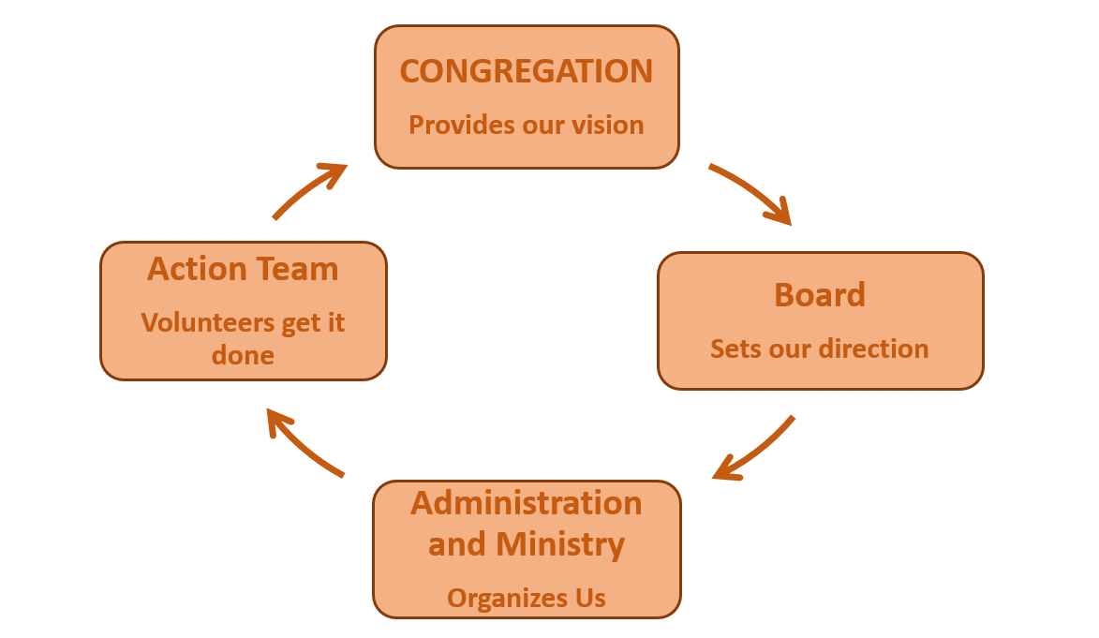

Accountability
The Administration and Ministry Team is accountable to the board and plays a key role in enabling the congregation to fulfill its ministry. The team will operate with the following principles.
- Alignment with the vision, mission and goals of the church. Ensuring all actions and decisions support the overarching direction of the congregation as set by the board.
- Participatory decision-making. Encouraging collaboration and input from key stakeholders within the congregation.
- Compliance with all applicable governance policies. Adhering to relevant rules, procedures, and policies to maintain accountability and transparency.

The Administration and Ministry Team will submit a report to the board at least every three months and it will include the following.
- An overview of how the team is operating in alignment with the principles stated above.
- The overall status of activities with emphasis on areas requiring board direction or input.

The board may request reports from the Administration and Ministry Team on specific areas of the church's ministry to ensure alignment with the overall vision, direction and program effectiveness.
The board and the Administration and Ministry Team will collaboratively review their working relationship annually, assessing how it aligns with the church’s vision, ministries and programs, and how they share leadership in guiding the congregation.

ADMINISTRATION AND MINISTRY TEAM
The Administration and Ministry Team has two primary functions that are guided by the vision and budget as determined by the board in alignment with the direction of the congregation.
- Provide leadership and delegation of administrative operations
- Provide leadership and delegation of programming

The Administration and Ministry Team comprises of the following members.
- Called/appointed ministers of St. Andrew’s Church
- Chair of Finance Committee
- Chair of Property Committee

The Administration and Ministry Team is empowered to organize and delegate the implementation of board goals to the action teams. They will provide oversight to ensure that the St. Andrew’s mission and ministry is aligned with the work of the congregation.
The following are some guidelines and expectations for this work.
- While the Administration and Ministry Team is accountable to the board for the implementation of the congregation’s goals and overseeing the church’s operations, it is expected that this will be done in collaboration with the action teams.
- The Administration and Ministry Team is composed both of lay leaders and called ministers. This is intended to help the ministers in their role and to provide support to the lay leaders.

The following is a checklist of expected responsibilities of the Administration and Ministry Team.
- Provide a rough plan for the year’s ministry and activities which builds on the strategic direction from the board
- Define and delegate administration and ministry tasks
- Ensure that budget is prepared for approval by the Board and the congregation
- Plan and assess leadership needs, development, and recruitment with the action teams
- Assist the Board with the annual evaluation of the life and the work of the congregation and assessment of their alignment with the strategic direction

The Administration and Ministry Team does not make policy and does not make decisions on how actions teams will achieve their goals.

ACTION TEAMS
Action teams will work within the following parameters.
- Action teams and their general duties will be defined by the congregational vision and strategic goals.
- Are responsible to the Administration and Ministry Team
- Carry out team work that supports the board vision, mission and goals
- Follow board policy in the actions taken
- Complete reporting as required by the Administration and Ministry Team
- Complete budgeting as required by the Administration and Ministry Team
- Responsible for communicating to the congregation with the support of the Communications Coordinator

Christian Development
GOALS
To provide leadership, represent and report to the board on the activities of the Christian Development committee including Camp Kasota East, Naramata, library, nursery, children’s ministry programs, and adult education programs. The purpose of the CD committee is to organize and implement Christian educational programs for all ages of the congregation of St. Andrew’s United Church to assist them to grow in love of God and neighbour.
RESPONSIBILITIES
A copy of the minutes will be sent electronically to the office as soon as possible.
Schedule CD meetings monthly. Committee consists of a minister, Church Program Coordinator, and other volunteers doing youth ministry or members at large from the congregation.
Chair is responsible to provide a written agenda ahead of time, chair CD committee meetings, and see that the secretary records and submits minutes.
Responsible to communicate via phone or invite to CD meetings the church’s representatives to Messy Church, Camp Kasota East, Naramata, church library, and nursery in order to obtain information, give information or discuss problems or concerns.
Ensure that the CD Annual Report includes all activities and is submitted to the Board by the end of December of each year. This would include Sunday School, Messy Church, Youth Group, Camp Kasota , Naramata, Adult Education, and any other youth and children’s ministries that the committee is responsible for.
Establish a budget in November of each year.
In January/February establish specific, measurable goals for the year. Share goals at the board meeting.
Attend the annual meeting to answer questions on behalf of CD.
Find child care for the Annual Meeting.
Provide bibles for Grade 4 class – work with Sunday School Coordinator.
Purchase and present gifts to the Coordinators of the children and youth programs in the spring – at the completion of Sunday School.
Assist minister and Church Program Coordinator in obtaining a coordinator for the Summer Camp program.
Assist the Summer Camp coordinator in planning the program if needed.
Be in dialogue with the ministerial team regarding adult education programming.

Congregational Life
GOALS
To provide leadership to Congregational Life (CL) Committee, represent and report to the Board on activities of the CL. The purpose of the CL committee is to provide opportunities for fellowship and encourage an atmosphere of open communication in order to build a warm and caring church community.
In other words, our purpose is threefold:
- Provide tools to foster open communication within the congregation
- Provide opportunities for fellowship
- Provide training, support and encouragement to help members of the congregation to care for each other

RESPONSIBILITIES
- E-mail the CL minutes to the church office.
- Attend special board meetings on the call of the Board Chair
- CL meets approximately once per month. Meetings may be attended by at least 2 CL members, additional volunteers, and a minister as needed. Arrange for a written agenda, a chair for the meeting, and a person to record the minutes.
- Ensure that a budget is prepared outlining anticipated expenses for the coming year, to be submitted to the Chair of the Finance Committee no later than the November Board meeting of the previous year.
- Ensure an annual report is prepared, outlining the accomplishments of the committee during the year, and goals for the coming year, to be submitted to the church office no later than the December board meeting of that year.
- Attend the annual general meeting, and be prepared to answer questions on behalf of the CL.
- Provide leadership to help the CL committee establish specific, measurable goals for the year.
Committee responsibilities
- Communications
- Review vehicles of communication within the church, such as the newsletter, Facebook page, Keeping-in-Touch, bulletins, informational brochures, and pamphlets. Liaise with people coordinating the communication.
- Identify and encourage other opportunities to enhance communication among church members.
- Organize the church photo directories approximately every 5 years.
- Fellowship
- Recruit volunteers for Sunday morning coffee
- Make sure that provision is made for a lunch and coffee for the annual meeting
- Organize the annual harvest potluck supper
- With the church school leaders, organize or assist with the spring congregational picnic
- Organize or assist with events which will nurture fellowship. Events could include: potluck suppers, games night, activities at coffee time to encourage mingling and interaction, members camping weekend
- Caring Community
- Organize events and gifts that will recognize grade 12 graduates, mothers on Mother’s Day, and fathers on Father’s Day
- Recognize milestone birthdays (90 and 95) and anniversaries (50 and 60)
- With the ministers’ help, assess the ways our church community cares for its members. This will include identifying people who have stopped coming to church, identifying and welcoming newcomers, and supporting people dealing with illness, grief, or other needs.
- Prayer Line, Keeping in Touch, Circles of Care, and Healing Pathway come under the purview of this committee.

Finance and Stewardship
GOALS
To provide leadership on the Financial Committee, report and advise the board on the finances of the church.
RESPONSIBILITIES
- Provide monthly or quarterly printed financial statement outlining the church's income and expenses of the past month (quarter) and year to date to the Admin Team
- Schedule FC meetings as needed, chair meetings and record minutes.
- Prepare yearly church budget
- Prepare a monthly financial report for printing in Morning Messenger.
- Attend the annual meeting to answer questions on behalf of the FC.
- Sign cheques (Cheques must have two signatures). E-transfer info.
- Collect the offering each Sunday following the service and put in safe.
- Review church rental schedule yearly, make changes and present to board for approval.
- In January/February provide leadership to help the FC committee establish specific, measurable goals for the year. Share goals at board meeting.

Skills, Experience, qualifications and/or personal qualities and traits needed
- Ability to work with numbers and interpret financial statements.
- Commitment to administering church finances.
- Leadership skills; especially organizational, presentation, communication and listening skills.
- Energetic
- Personable
- Able to work cooperatively with others.

Orientation and Training available
Orientation from previous FC board representative.

Training and support from clergy.

Support, accountability, and evaluation includes
- Support is from the chairman of the board
- Accountability is to the church board, clergy & congregation.
- Evaluation is by church board, clergy and the entire congregation

Ministry and Personnel
The Ministry and Personnel Committee is a Committee of trust and confidentiality that provides for the support, assessment, and consultation of all Ministry Personnel and Non-ministerial Staff of the Congregation of St. Andrew’s United Church.
The M&P Committee shall consist of 6 members (Members) who are appointed by the Board. Appointments shall be for a 3 year term with appointments made on a rotational basis such that 2 Members join the M&P Committee each year and 2 Members retire each year.
Generally, the M&P Committee shall be responsible to:
- Serve as a liaison between and among the Congregation and Ministry Personnel and Non-ministerial Staff establishing and maintaining a respectful and supportive environment.
- Listen and receive feedback from the Congregation and share such with staff.
- Ensure that each Ministry Personnel and Non-ministerial Staff member is assigned an individual Member of the M&P Committee through whom regular and open communication is initiated and maintained.
- Reviews salaries, allowances, benefits, Honoraria, and working conditions, makes recommendations to the Board during Budget planning.
- Maintain appropriate confidentiality and control of all written information and materials of the M&P Committee.
- Track vacation schedules and ensure supports are in place during vacation absences.
- Become and remain familiar with resources available through Presbytery, Conference, and General Council of the UCC to enhance the Committee’s effectiveness.

Outreach
Mission Statement: ‘To co-ordinate, support and promote the congregation’s outreach activities at a local, national and international level.’ We are concerned about many kinds of needs: spiritual, emotional, physical and social.
GOALS
- To celebrate the work of various outreach projects and thank those involved.
- To facilitate communication between outreach ministries, board and congregation.
- To assess the need for new activities and ministries.
- To choose a study topic each year to educate the congregation, the community and ourselves.
- Help promote the M&S fund with the board and congregation.
- To complement financial support with hands-on, practical experience in mission and development projects.
- To recommend annual goals for education, service and financial support for local, national and international outreach.

Committees and/or programs that fall within the purview of Outreach include Central Alberta Foodgrains Growing Project, Friends of Guatemala (F.R.O.G.), Lacombe &District Volunteer Link, Living in Right Relationships (LIRR), Lacombe FCSS Meals on Wheels, FCSS Benevolent Fund, Amnesty International Write for Rights – December 10 of each year, and United Church Mission and Service Fund.

Property
GOALS
The Property Committee is responsible to ensure that our building and grounds are kept to a standard that facilitates the mission of our congregation.

Monitor function of building utilities (lighting, heating, emergency systems).

Implement routine repairs and minor improvements.

Participate in implementation and oversight of major repairs and upgrades.

Establish and implement periodic preventive maintenance programs.

Work with janitors, custodians and groundskeepers with respect to responsibilities and terms of
contract (formal contracts and salaries are M&P responsibility).

RESPONSIBILITIES
- Submit a Property Committee report to the Admin Team highlighting activities, achievements and concerns.
- Conduct Property Committee meetings as required to plan activities, including preventative maintenance and upgrades. Keep minutes and submit to office.
- Prepare a Property Committee report for the church’s annual report.
- Attend annual congregational meeting to answer questions on behalf of the Property Committee.
- Develop and manage an annual plan and budget for the Property Committee.
- Ensure adequate and cost-effective property and liability insurance.
- Monitor and maintain utility systems (heat, electrical power and water), the building structure (interior and exterior), and emergency systems.
- Ensure that professional inspection and testing of fire protection systems, burglar alarm, and elevator is kept up-to-date, and that legally required licensing is up-to-date.
- Implement energy conservation upgrades where feasible.
- Develop and implement a schedule of important periodic work.
- Maintain equipment information and service schedules.

- Provide supplementary lawn care – aeration, dethatching, fertilizing and weed control as required.
- Identify major maintenance and upgrade projects needed. Work with the Board to develop implementation strategies.
- Organize and manage volunteers and contractors as required to achieve Property Committee objectives.
- Plan and implement minor remodeling or upgrading projects using volunteers or contractors as required.
- Supervise work included in janitorial/custodial/groundskeeper contracts.
- Work cooperatively with M & P committee to develop janitorial/custodial/groundskeeper job descriptions and contracts.

Worship
The purpose of the Worship Committee is to encourage spiritual challenge, intellectual enrichment and caring concern for each other, our community and the world through words, music and physical symbols.

The Worship Committee assists the Minister in planning and evaluating the worship life of the congregation, to make people of all ages feel invited and welcomed into a joyful and warm worshiping community.
The Worship Committee consists of one minister and volunteers from the congregation. It meets monthly except July. A Chairperson and secretary are appointed. A written agenda is prepared and minutes kept and submitted to the office.
Time commitment consists of a monthly meeting of approximately 2 hours, preparation of communion in turn with other committee members and about 5 hours a year for different projects.
RESPONSIBILITIES
- Plan and evaluate worship services.
- Plan and revise policies and procedures about worship.
- Plan and prepare for communion.
- Establish specific measurable goals yearly.
- Prepare an annual report and budget.
- Recruit choir director(s).
- Arrange organist/pianist every Sunday
- Arrange Audio Visual people every Sunday.
- Arrange Special Music, Hymn Leaders, and Gathering Music.
- Set honoraria for organist, pianist, accompanist, and choir director(s).
- Decorate sanctuary for special occasions like Christmas or Easter.
- Arrange pulpit supply during ministerial absence.
- Recruit usher/server, driving and banner coordinators.
- Introducing pulpit supply or new ministers
- Keep worship handbook current and ensure all members have a copy.

In addition the church board members will:
- Attend church board meeting monthly with a written summary or minutes of the activities of the committee.
- Attend special board meetings on the call of the chairman.
- Attend annual meeting to answer questions on behalf of the Worship Committee.

Volunteer benefits are an opportunity to serve others and with others as well as an opportunity for personal and spiritual growth.
Qualifications-Interest in and commitment to effective worship, ability to work cooperatively with others, ability to conduct a business meeting, leadership skills, is personable and energetic.
Orientation and training in information booklet and from other Worship Committee members.
The Worship Committee is accountable to the clergy, the congregation and the church board.

United Church Women (UCW)
PURPOSE
To unite all women of the congregation for the total mission of the Church and to provide a medium through which they may express their loyalty and devotion to Jesus Christ in Christian witness, study, fellowship, and service.
St. Andrew’s currently has two UCW groups. The groups each hold meetings once a month from September to June.

Staffing
Ministers: Reverend Dave Holmes
Reverend Bob Settle, Honorary Associate Minister
Duty of Care Co-ordinator: often filled by one of the ministers.
Office Administration: Jana Figursky
Children’s Program Coordinator:
Custodial staff: Jill Hair. Covers the inside of the church.
Groundskeeper: Terry Souveny
Security staff: Diane Hayduk - opening and closing and setup for functions.
UNITED CHURCH STRUCTURE

General Council

General Council Executive

Chinook Winds Region

St. Andrew’s United Church Congregation

Church Board

Committees and Ad Hoc Committees

Christian Development (Sunday School, Camp Kasota, Messy Church, VBS, SAUCY (Youth Group), Confirmation, Book Study, Adult Education), Affirm, Congregational Life (Keeping in Touch, Circles of Care, Prayer Line, Healing Pathway), Finance & Stewardship, Ministry & Personnel, Outreach (Central Alberta Food Grains Project, Friends of Guatemala (FROG), Lacombe and District Volunteer Link, Living in Right Relations (LIRR), Lacombe FCSS-Meals on Wheels, Mission and Service Fund), Property, Worship, Trustees, UCW, and Ad Hoc committees such as the Nominating Committee and other committees as determined by the Church Board.
