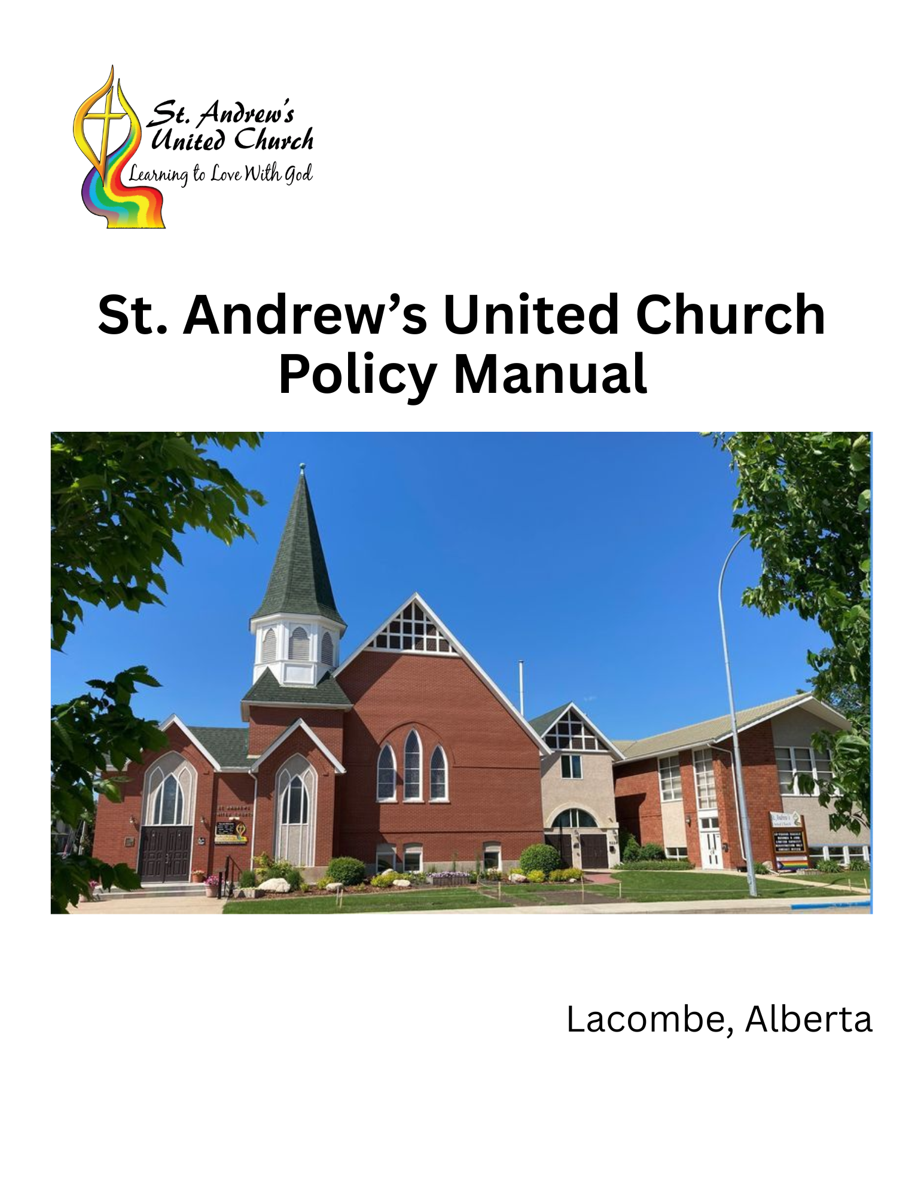

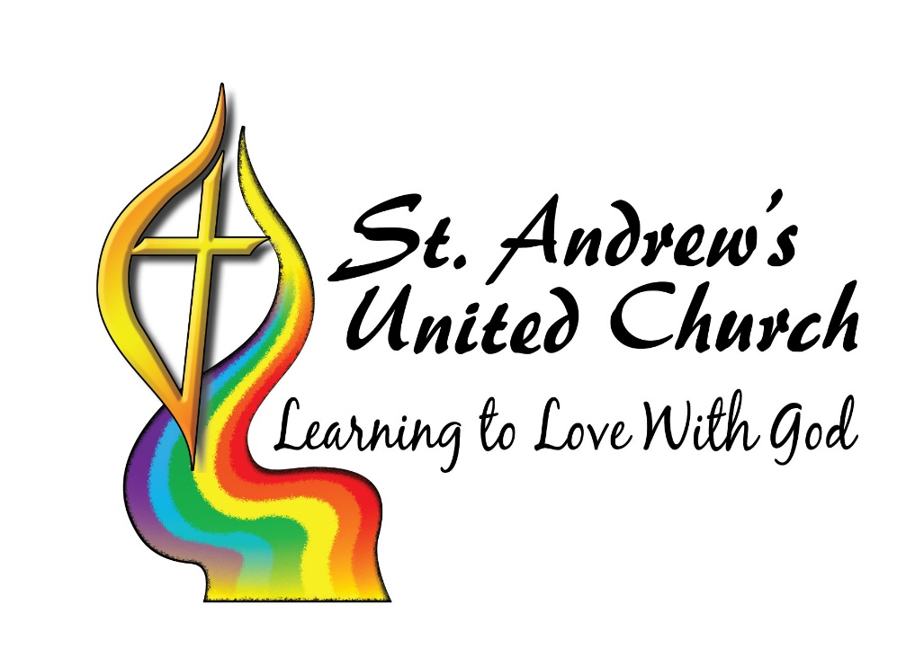
MISSION
St. Andrew’s United Church strives to be a caring Christian community that nurtures love of God and neighbour through worship, fellowship, learning, and service.

Contents
Administration 5
Affirming Congregation 5
Baptism 6
Board (Congregational Meeting, April 6, 2025, Page 8-17) 8
Regional Representation at Board meetings 10
Roles and Responsibilities of Board Members 10
Expectations of Board Members 11
Removal of Board Members 12
Board Chair 12
Board Secretary 13
Regional Representative 13
COMMITTEES OF THE BOARD 13
Ministry and Personnel Committee 13
Hiring Committee 13
Board of Trustees 14
Nominating Committee 14
Policy Committee 14
DELEGATION AND ACCOUNTABILITY 14
Delegation of Authority 14
Accountability 15
ADMINISTRATION AND MINISTRY TEAM 16
ACTION TEAMS 17
Church Use Policy 17
Community 18
Duty Of Care Policy For Volunteers 19
1. Introduction 19
Emergency/Safety Policy 26
Environmental Policy 26
Finance 26
Fund Raising 26
Funeral Policy 27
Legacy Policy 28
Membership Policy 35
Memorial Fund 35
Mission, Vision, Values, Philosophy, Outcomes (April 6, 2025) 36
Pastoral Hosted Trip Recommendations 39
Property 40
Rental Policy (2024) 40
Sunday School 43
Trustees 43
Wedding Policy 43
Youth Volunteer Age Policy 44

Administration
Policy 55/2004
An accident report form must be completed in the event that an incident occurs.
Policy 60/2004
The Board will designate a Privacy Officer for St. Andrew’s United Church.
Policy 4/2/2019
All cheques are to have two signatures. Only one Office Administrator can sign and the other must be a signor from the Finance Committee.
Policy 003/06/2022
St. Andrew’s will have a credit card for church business. The office personnel will be responsible for the use of the church Business No-Fee Mastercard. The expenditures for this credit card require approval from the board. Examples of expected uses are: Ongoing or repetitive expenses such as subscriptions for technological services or platforms (ZOOM, CANVA, Microsoft 365, music licenses, etc.: one-time large expenditures from a vendor where we do not have an account: On-line purchases that require payment at time of ordering (eg. book orders for programs). Expenditure Tracking and Accountability – The bookkeeper will monitor usage and ensure timely payment (auto payment to be set up to avoid late payment and interest fees). The finance committee will review the monthly statements. Procedure – Any proposed expenditures that have not been pre-approved through the budget process are to be approved by the board. Following approval, the Bookkeeper will be notified of the upcoming expenditure, and the expenditure information will be sent to the designated staff member to complete the purchase. Receipts are to be sent to the Bookkeeper for review, reconciliation, and payment.

Affirming Congregation
Policy 27/2011
St. Andrew’s United Church is an Affirming Ministry as defined by the Affirming Ministries program of the United Church of Canada.

Baptism
The Baptism of Infants and Young Children at St. Andrew's United Church
Policy Statement 1995, revised 2004, 03/2008

Board Approval: Except in emergency situations, all candidates for baptism will be approved by the board.
Baptism or Blessing: Families will be offered a choice between a service of blessing without expectation, or a service of baptism where parents are prepared to make the commitments of baptism.
Membership Requirement:
1. At least one parent will normally be a baptized and confirmed member of this congregation, in good standing. "In good standing" means that the person should be an active participant in the life and work of the congregation.
2. Exceptions to the membership requirement may be made, with the consent of the board, in the case of active adherents. However, since baptism involves a commitment to encourage their own children to achieve full membership, it would be more consistent for active adherents to become members of the congregation before or at the same time as the baptism of their child(ren).
Encouraging Commitment to Christian Community:
1. In the case of those who have not recently participated in the life of the congregation, then the request for baptism will be seen as an opportunity to invite the family to participate actively in the life of the congregation. Parents should be strongly encouraged not to wait until their children are old enough before beginning this active participation. Such a delay models the idea that spiritual growth is completed in childhood, and that the church as a community of faith and service is optional for adult Christians.
2. The parents should demonstrate some evidence of their intention to become active before the board is asked to approve the baptism. Such evidence should include at least one of the following: participation in Sunday worship, study or fellowship groups or UCW, leadership in Sunday School or some other activity of the congregation, leadership or support of the outreach activities of the congregation (support of refugees, collective kitchens, etc.).
3. Parents will be asked to develop a plan for the Christian Education of their children. The plan will normally include home activities (e.g. graces at meals, Bible reading), church participation (e.g. Sunday morning, youth groups) and age-appropriate service to the community.

Families from Out of Town:
1. Families who do not live in Lacombe, but wish to have children baptized at St. Andrew's because of family or historic connections will be encouraged to have the baptism performed in their local congregation, but the baptism may be performed in St. Andrew's provided that the couple has demonstrated a commitment to their local congregation, such commitment to be certified by a letter of recommendation from the minister or other official of the church. Instruction and preparation for baptism may be held in that other congregation provided that it covers similar ground as the program offered at St. Andrew's.
2. One of the ministers of St. Andrew's will read the letter of recommendation or a part of it, as appropriate, as part of the baptismal service, and will request that prayers for the family be offered as part of the service in the other congregation on that Sunday.
3. Parents will be asked to develop a plan for the Christian Education of their children. The plan will normally include home activities (e.g. graces at meals, Bible reading), church participation (e.g. Sunday morning, youth groups) and age-appropriate service to the community. In circumstances where there is no United Church or other suitable congregation, this plan may be accepted as an alternative to participation in a local congregation.
Church Programming for Baptism:
1. A program of preparation for members presenting children for baptism will be scheduled at a mutually convenient time. This program will normally involve one or two two-hour seminars, reviewing the theology of baptism, the vows to be taken, and offering the opportunity to discuss and explore how the parents intend to fulfill the commitment to "show [their] children the Christian life and to grow with them in faith."
2. A program of preparation for teenagers and adults seeking baptism and / or confirmation for themselves and/or their children will be offered at least once a year. These programs may be individually designed to meet special needs, but normally will be group programs involving six to ten two-hour meetings.
3. To fulfill its obligations to parents who present children for baptism, the board will host gatherings at least once a year for all parents who have had children baptized recently, possibly in conjunction with a gathering of newcomers. This gathering will be the responsibility of the Congregational Life committee.
4. While it remains the responsibility of the family to honour the commitments that they make, the minister will contact families who have had children baptized recently, but are not participating regularly, to inquire, in a gentle and supportive way, about any problems they are having in honouring their vows.

Board (Congregational Meeting, April 6, 2025, Page 8-17)
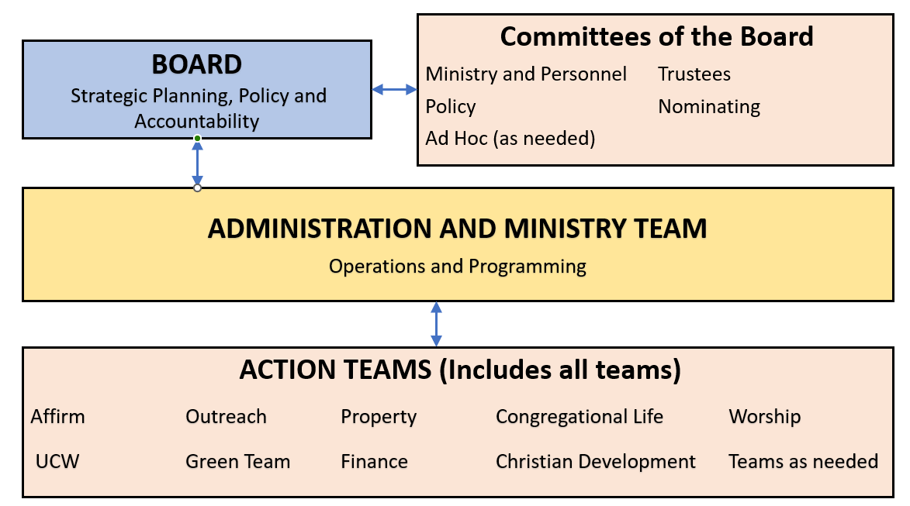
The St. Andrew’s Church Board (board) leads the congregation in ensuring that it understands and carries out its Mission as a Community of Faith in Jesus Christ.
The board consists of the members below who will be elected at the Annual Congregational Meeting. Each member may serve a maximum of 2 three-year terms. The board chair is elected annually for a 1-year term and may serve up to three terms consecutively. A board member or chair must have at least one year not served before they may serve again. The board chair must be a member of St. Andrew’s Church. Other members of the board are to be a member or adherent of St. Andrews Church.
The board consists of 9 elected members and the called ministers as listed below.
- Chair
- Board Secretary
- Treasurer
- Ministry and Personnel Committee Representative
- Chair of Finance Committee
- Chair of Property Committee
- Chinook Winds United Church Regional Representative (Regional Representative)
- Member at large (2 positions)
- Called Ministers

All board members shall have voting power. However, the Board Chair shall only exercise their vote at the board level in the event of a tie.
Quorum for the board shall consist of five of the nine elected members and one called minister. In the event that a called minister is unable to be present, an appointed regional minister representative may fill in. A quorum must be present for any vote or decision to occur, however a meeting may proceed as an information session, but no voting or decision may be made.
Board members must recuse themselves from any conflicts of interest. See Conflict of Interest Policy.
Only board members are voted in at the Annual Congregational Meeting. Action team chairs and members will be determined at the Administration and Ministry Team level.
The following positions are nominated and elected by the membership as a whole at the Annual Congregational Meeting.
- Chair
- Board Secretary
- Regional Representative (2 positions)
- Member at Large (2 positions)
- Chair of the Finance Committee
- Chair of the Property Committee

The following positions are appointed by the finance committee and the board and the congregation is informed at the Annual Congregational Meeting.
- Treasurer - Finance Committee
- Ministry and Personnel Committee Chair and committee members - Board

Regional Representation at Board meetings
Up to two regional representatives may be elected to represent the congregation at the regional level. However, only one regional representative will sit on the board at any given time, with the representatives determining amongst themselves who will serve. If the primary representative is unable to attend a board meeting, the alternate representative may fill in.

Roles and Responsibilities of Board Members
Reference: The Manual of The United Church of Canada, (current edition)
The board is responsible for the items listed below.
Strategic Direction
- Development of Mission, Vision and Value statements
- Long term Vision for the ministry – 3 to 5 years
- Short term Vision for the ministry – annual goals
Oversight of the local administration
- Finances
- Governance
Staff oversight and program
- Hiring, firing and discipline of lay staff
- Advocacy for the lay and ministry staff through the Ministry and Personnel Committee
- Oversight and Discipline of Ministry Personnel through the United Church Office of Vocation
Delegation
- Delegation of goal implementation to Administration and Ministry team
Policy
- Policy decisions
- Policy review and update
Engagement with the congregation
- Use different approaches of engagement to ensure that the congregation has a voice

Expectations of Board Members
The board is the body empowered by the congregation to have oversight over the congregation’s ministry and affairs. The board is responsible for ongoing congregational engagement as part of their visioning process. After delegating the administrative operations and ministries of the church to the Administration and Ministry Team and action teams, the primary work of the board is oversight, and attention to the mission and vision of the church. As such, it is important for the board to provide both leadership in these things, and embody the vision and values of the congregation in how they do these things.
The following are expectations of all board members, expressed as a covenant to be signed by each board member at the first meeting of each new board.
Board members are expected to the best of their abilities to:
Prepare for board meetings: Read pre-meeting packages before the meeting and seek additional information as needed to actively participate in board business.
Attend all board meetings: If you are unable to attend, inform the board chair as soon as possible.
Participate in board meetings: Listen with curiosity, speak with honesty and respect, and always keep in mind the congregation’s mission and values.
Contribute to board activities: Support board initiatives outside of meetings. Participate in events, volunteer opportunities, and build relationships with church members.
Treat one another with respect: Abide by the congregation’s values, follow conflict resolution procedures, and uphold our covenant of care for one another.
Maintain confidentiality: Do not discuss board matters or opinions shared by other members of the board outside of meetings. Honor confidentiality agreements made regarding specific matters and address concerns with the board chair as needed.
Respect board decisions: Speak respectfully of board decisions and the boards authority to make final decisions, even when individual members may respectfully disagree.
Conflict of Interest: Abide by the Conflict of Interest policy and promptly disclose any conflicts to the board or chair.
Personal spiritual growth: Attend to your own spiritual growth and well-being, both as a board member and in your personal lives.
Scheduling of board meetings will be determined by the board and all members are expected to attend a board retreat (1 to 2 days) once a year.

Removal of Board Members
A Board member may be removed before the end of their term by a vote of the board for any of the following reasons.
Resignation: Formal voluntary departure from the board.
Relocation: Moving away from the area, making continued service impractical.
Leaving the United Church Denomination: Ceasing to be a member of the church.
Excessive absence: Frequent or prolonged absent from board meeting without valid reason, including, but not limited to, three consecutive absences.
Exhibiting unsuitable behavior: Engaging in actions such as violating the code of conduct, being disruptive, not abiding by board expectations or failing to fulfill board duties.
Other reasons: Any other reasons deemed necessary by the board for the well-being of the congregation and its governance.

Board Chair
The chair provides leadership to the church board, ensuring that issues are discussed thoroughly and fairly and that disagreements are dealt with openly and respectfully.
Proficiencies
- Ability to conduct meetings using Bourinot’s Rules of Order.
- Commitment to the success of the church’s vision
- Leadership skills: organization, communication, listening, delegation, negotiation and facilitation.
- Energetic and personable.
- Ability to work cooperatively with others.
- Working knowledge of church policies and procedures.
- Preferably has completed two years on the board prior to assuming the Chair position

Roles and responsibilities
- Calls, attends, and chairs regular church board meetings.
- Calls, attends, and chairs special board meetings as needed.
- In collaboration with the board secretary, provides for distribution a written agenda.
- Chairs all congregation of the whole meetings.
- Chairs all meetings in according to Bourinot’s Rules of Order
- Prepares the agenda for annual congregational meeting.
- Trains new board members and offers guidance as necessary.
- Writes and submits annual board report to office by January 31 for the prior year ending December 31.

Board Secretary
The Board secretary will be responsible for the following items.
- Take meeting minutes
- Provide minutes to the church office for distribution, and recordkeeping
- In collaboration with the board chair, provide a written agenda for distribution.
- Communicate board messages to the congregation with the support of the Communications Coordinator
- Manage correspondence to the board

Regional Representative
Chinook Winds Regional Representative communicates information from the Region to the Board and from the Board to the Region.

COMMITTEES OF THE BOARD

Ministry and Personnel Committee
References: Ministry and Personnel Committees: Policy, Procedures, Practices Handbook (current edition).
The Ministry and Personnel Committee is a committee of trust and confidentiality that has three distinct roles: the consultative and supportive role, the healthy relationships role, and the supervisory role. These roles are helpful lenses through which to see the best practices, which can be used to fulfill the Ministry and Personnel Committee’s responsibilities, according to each policy statement within the manual.

Hiring Committee
The hiring committee is an ad hoc committee and will be formed as required for the hiring of lay staff and be tailored to suit the needs for each particular hire. It will have at least one representative from the Ministry and Personnel Committee.

Board of Trustees
The Trustees for St. Andrew’s United Church consists of the following board members.
- The Chair of the Finance Committee
- The Chair of the Property Committee
- The Chair of St. Andrew’s Board
- Chinook Winds United Church Region Representative
- St. Andrew’s pro tempore called minister
The trustees are confirmed at the Annual Congregational Meeting.

Nominating Committee
The nominating committee is an ad hoc committee that meets as needed to search for suitable lay candidates to serve on the board and committees of the board. Members of the nominating committee consist of volunteers from the board and others from the congregation.
Names are to be brought forward by the nominating committee for election at the Annual Congregational Meeting.

Policy Committee
The policy committee is responsible for the development, review and maintenance of policies of the board. The committee will be chaired by a member of the board and consist of any board approved congregation members. Priorities of policy work will be provided by the board.

DELEGATION AND ACCOUNTABILITY

Delegation of Authority
The congregation, through the board, delegates authority to the Administration and Ministry Team to organize operations and ministry of the church. The Administration and Ministry Team will work to create a permission giving, participatory structure that delegates responsibility to action teams, ensures effective accountability, and fulfills the vision and mission of St Andrew’s United Church.

Delegation of Authority
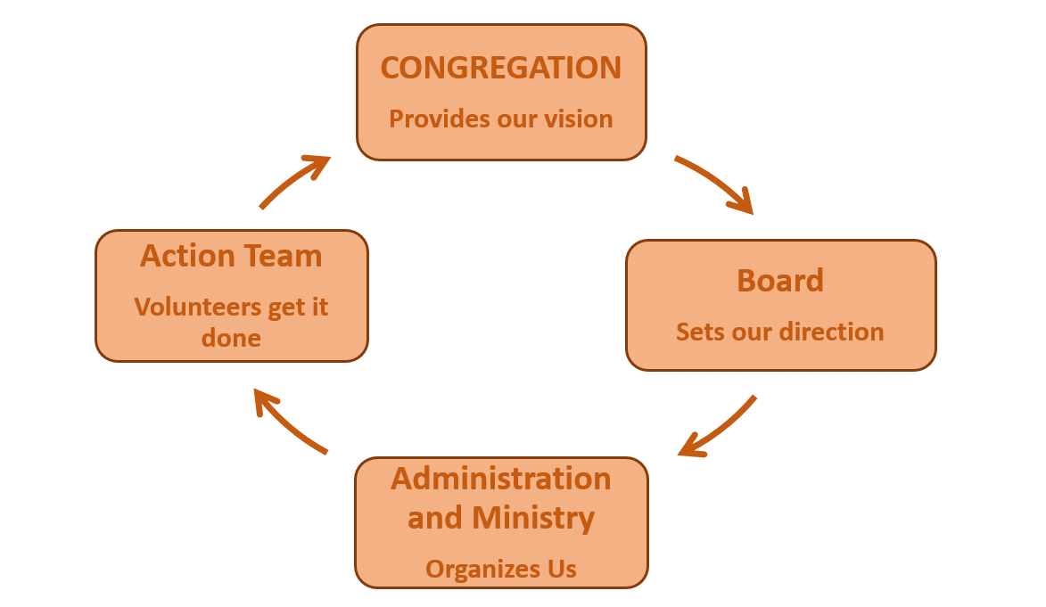

Accountability
The Administration and Ministry Team is accountable to the board and plays a key role in enabling the congregation to fulfill its ministry. The team will operate with the following principles.
- Alignment with the vision, mission and goals of the church. Ensuring all actions and decisions support the overarching direction of the congregation as set by the board.
- Participatory decision-making. Encouraging collaboration and input from key stakeholders within the congregation.
- Compliance with all applicable governance policies. Adhering to relevant rules, procedures, and policies to maintain accountability and transparency.

The Administration and Ministry Team will submit a report to the board at least every three months and it will include the following.
- An overview of how the team is operating in alignment with the principles stated above.
- The overall status of activities with emphasis on areas requiring board direction or input.

The board may request reports from the Administration and Ministry Team on specific areas of the church's ministry to ensure alignment with the overall vision, direction and program effectiveness.
The board and the Administration and Ministry Team will collaboratively review their working relationship annually, assessing how it aligns with the church’s vision, ministries and programs, and how they share leadership in guiding the congregation.

ADMINISTRATION AND MINISTRY TEAM

The Administration and Ministry Team has two primary functions that are guided by the vision and budget as determined by the board in alignment with the direction of the congregation.
- Provide leadership and delegation of administrative operations
- Provide leadership and delegation of programming

The Administration and Ministry Team comprises of the following members.
- Called/appointed ministers of St. Andrew’s Church
- Chair of Finance Committee
- Chair of Property Committee

The Administration and Ministry Team is empowered to organize and delegate the implementation of board goals to the action teams. They will provide oversight to ensure that the St. Andrew’s mission and ministry is aligned with the work of the congregation.
The following are some guidelines and expectations for this work.
- While the Administration and Ministry Team is accountable to the board for the implementation of the congregation’s goals and overseeing the church’s operations, it is expected that this will be done in collaboration with the action teams.
- The Administration and Ministry Team is composed both of lay leaders and called ministers. This is intended to help the ministers in their role and to provide support to the lay leaders.

The following is a checklist of expected responsibilities of the Administration and Ministry Team.
- Provide a rough plan for the year’s ministry and activities which builds on the strategic direction from the board
- Define and delegate administration and ministry tasks
- Ensure that budget is prepared for approval by the Board and the congregation
- Plan and assess leadership needs, development, and recruitment with the action teams
- Assist the Board with the annual evaluation of the life and the work of the congregation and assessment of their alignment with the strategic direction

The Administration and Ministry Team does not make policy and does not make decisions on how actions teams will achieve their goals.

ACTION TEAMS
Reference: St. Andrew’s United Church Handbook.
Action teams will work within the following parameters.
- Action teams and their general duties will be defined by the congregational vision and strategic goals.
- Are responsible to the Administration and Ministry Team
- Carry out team work that supports the board vision, mission and goals
- Follow board policy in the actions taken
- Complete reporting as required by the Administration and Ministry Team
- Complete budgeting as required by the Administration and Ministry Team
- Responsible for communicating to the congregation with the support of the Communications Coordinator

Church Use Policy

Policy 29/2009, Revised A5/2016, Revised 7/11/2020

THE CHURCH BUILDING is the home of an open and diverse congregation that is committed to worship and service as expressions of God's love. The congregation willingly shares the use of the building with many groups, but we do request that groups using the church do so with respect for the congregation that meets here. The sanctuary in particular is a special place for which we ask user groups show deep respect. If you have questions about whether your use of the sanctuary may be considered disrespectful, please consult with the church staff.

Beverages in enclosed containers are welcome

The rental fee charged includes:
1. Use of spaces booked, plus washrooms
2. Opening and closing the church
3. Cleaning before and after
4. Sound System operator provided for funerals, weddings and rehearsals

SOUND SYSTEM: The sound system in the sanctuary is only available if one of the operators trained by the church is present to run it. The fee for such an operator is included in the fee charged for funerals and weddings. For all other uses, an extra fee will be charged. It is not always possible to arrange for an operator to be present, so if the sound system is needed, the request must be made at the time of booking.

DAMAGES: All users are responsible for any damages to or loss of property
The church is not responsible for any accident or injury incurred while using the facility
The use of the facility shall be authorized for a specific area and time. The group using the facility shall be responsible to see that only requested sections of the facility are used.
The group is responsible for proper restoration of the facility and replacement of equipment etc.
No tape will be used for pew markers, or on walls
SET UP / CLEAN UP: Set up of tables and chairs are the responsibility of the Custodian. The facility must be left in the same condition as it was found. If any decorations were removed, they must be replaced, and the kitchen must be left clean.

BOOKING: Booking forms are available at the office and must be completed.

ALCOHOL AND SMOKING POLICY: Alcohol is not allowed in the building without the express prior written permission of the church board. Smoking is not permitted in the building, no exceptions.
Please note that the sanctuary may be decorated for special events (Christmas, Easter etc.). Therefore, the day of your event, the sanctuary may not be exactly as it was when you first booked. The sanctuary MUST be left as you found it.

INSURANCE: St. Andrew's United Church recommends that renters obtain event liability insurance for their own protection, in case they are liable for injury or property damage. Insurance is available from local agents and brokers, and also at reasonable rates from the United Church of Canada's insurer, HUB International. The HUB event liability insurance web page is currently located at
http://www.hkmb.com/industry/sportsent/HKMBUCC_TPEL.asp and the location code for St. Andrew's United Church is 1657. HUB's phone number is 1-888-550-5458

Community
Policy 03/42021
In the event of an emergency during inclement weather and the buildings need to be evacuated, St. Andrew’s United Church and the Lacombe Memorial Centre agree to the use of each other’s buildings. Contact information should be made available to all Board members.

Duty Of Care Policy For Volunteers

Policy 68/16

MISSION STATEMENT

St. Andrew’s United Church strives to be a caring Christian community that nurtures love of God and neighbour through worship, fellowship, learning, and service.

1. Introduction

The United Church of Canada (UCC) has a legal, moral, and spiritual obligation to care for and protect participants and volunteers/staff in our church programs. This is a legal principle called “Duty of Care”, and church groups have been, and will be, held legally responsible for ensuring reasonable measures are taken to ensure safety. (Faithful Footsteps, United Church of Canada)

It is a central moral and spiritual obligation to ensure our most vulnerable participants are protected from danger.

The St. Andrew’s community will continue to be a place that is welcome to everyone and is safe for people of all walks of life. At the same time, it is prudent that the church be vigilant in its efforts to create and maintain safe environments and safe services for all participants. These efforts will include paying attention to physical space, the types of participants, appropriate recruitment, screening, training and support of leaders, as well as protection of leaders from difficult or threatening situations.

2. Terminology

Duty of care

Duty of care is the obligation that one owes the other, especially the obligations to exercise reasonable care with respect to the interests of the other. This obligation includes protection from harm.

Position of trust

- Situations in which someone has a significant degree of authority or decision-making power over another; and/or unsupervised access to another person and to his/her property.

- Situations where the success of the service depends on the development of a close, personal relationship between the individuals as in mentoring or friendly visiting programs.

Volunteers

A volunteer is an individual:
- who chooses to undertake a service or activity – someone who is not coerced or compelled to do this activity;
- who does this activity in service for an individual or an organization, or to assist the community-at-large;
- who does not receive a salary or wage for this service or activity.

Vulnerable person

One who has difficulty protecting him/herself from harm temporarily or permanently and is at risk because of age, disability, handicap or situation.

- Children/youth – participating in Sunday School, (Nursery, if a program), Youth Programs, on-or-off-site camps, and/or counselling and other programs.
- Seniors – at the Church, in a public location, or in a private location such as home or vehicle.
- Persons with Disabilities – as above.
- Persons who are experiencing difficult life transitions and are emotionally susceptible.

3. Statement of Commitment

St. Andrew’s United Church is committed to providing a safe environment for all congregational activities: worship, work, study and fellowship. In addition, all activities that take place with other institutions, agencies, and organisations and are in any way under the St. Andrew’s name are included. St. Andrew’s seeks to ensure that all staff, volunteers and ministry personnel share this commitment.

4. Theological Statement

Jesus came into the world to bring life in all its fullness. As followers of Jesus we are called to show love to one another, and to the world (John 13:34-35), to share our gifts and resources, and to build a community of mutuality and respect (Acts 3: 44-47). As a church, we have a primary duty to care for those who are marginalized, less powerful or more vulnerable in our community. (Deuteronomy 10:17-19, Isaiah 61:1&2)
Jesus teaches us that we must love one another. Love does not insist upon its own way. (Corinthians 13:5). Jesus reminds us that as we do to the most vulnerable among us we do unto him (Matthew 25: 35-40).
St. Andrew’s is blessed with the gifts of many people who offer their leadership, time, and talents as volunteers.

5. Elements of “Duty of Care”

The primary elements involved in exercising “Duty of Care” are:

- Position Descriptions
- Assessing Risk
- Screening

It is through the assessing of risk for the various activities that take place and undertaking the appropriate screening that the “Duty of Care” is exercised.

Assessing Risk considers a number of factors:

- Vulnerability of participants – age, dependencies, group situations or one-on-one
- The setting of the activity – rooms with windows in the door, off-site public or private locations
- The activity – group or one on one, physically active or passive, demanding of privacy
- Supervision provided – documentation kept, spot checks conducted
- Relationship between participant and volunteer/staff– power differential between volunteer or staff and participant, level of trust, activity dependent upon fostering a close and personal relationship

Risk will be assessed into one of three levels:

- Low Risk: minimal or no contact with vulnerable people and programs take place in large groups
- Medium Risk: activities with vulnerable people, but no private or one-on-one settings.
- High Risk: position presents opportunities to be alone with vulnerable persons, or opportunities to exert influence over them.

Defining meaningful screening:

Appropriate screening requirements relate to the position or function that may occur and has no relationship to an individual. It is about creating and maintaining a safe environment for participants, leadership, volunteer or staff, through understood matching of skills and tasks.

Activities may include:

- Defining the nature of the position and writing a job description
- Recruiting based on job description and required skills
- Using application forms to record defined required information
- Interviewing candidates either formally or informally
- Checking references
- Requesting police records checks for positions classed as medium or high risk
- Providing orientation and training as required
- Providing supervision and regular evaluation feedback
- Checking with program participants on how the ministry is operating

*** While all of the above aspects are important, information received through the application form, interviews, and reference checks are key in the initial set up. Example: Application forms for Sunday School teachers and the supporting documents need to be kept in a locked filing cabinet in the office. Supervision would be important throughout the year.

6. Duty of Care Coordinator.

Generally, a staff member will be designated to be the Duty of Care Coordinator. The Board can also designate a lay person to this position. This person will hold the application forms, keep track of references, police checks, and generally ensures that the policy is followed.

7. Procedures for Duty of Care

The following Steps will be put in place to maintain and enhance a safe environment:

- The “Duty of Care” procedures apply to all activities conducted by volunteers.
- All activities must be listed and kept current by standing committees
- A consolidated master list of activities shall be maintained in the church office.
- All activities will be risk assessed and categorised as Low, Medium or High by the relevant committee chair.
- For all activities assessed as Low, no further action need be taken
- For activities/functions assessed as Medium or High, a Position Description or Activity Description shall be prepared that outlines the key elements of the position/activity as it relates to risk assessment. The documents need not be detailed for each position or activity but may be general in nature and may cover activities or positions in many areas.
(Example: Sunday School teachers, one position description for Junior and one for Senior may suffice.)
- For activities assessed as Medium or High, a “Risk Assessment Form” (Appendix B) shall be filled in defining the area of risk and defining any actions that need to be taken to mitigate or communicate the assessed risks.
- Committee Chairs will, at least once per year, review the safety of the environment encompassed by the activity and keep records of that review. The review may be detailed or simple depending on the nature of the activity. Guidelines in Appendix A, and the Appendix B form should be considered. If the risk has changed, the assessment needs to reflect this.

8. Police Record Checks

All volunteers involved in Medium or High Risk activities will be required to submit a current Police Record Check (PRC) to the Duty of Care Coordinator. The Police Record Check will be renewed every 3 years. An additional screen called a “vulnerable sector check” is available if further information is needed. Some volunteer organizations also require a further screen through Child and Family Services called the “Child and Youth Intervention Module” where the name is searched through the Child Protection database.

Where a PRC is required it must be submitted to the Duty of Care Coordinator for review before the volunteer begins involvement in the activity. A photocopy will be kept on file. Where a PRC identifies information that may contravene the acceptable standards of risk then a decision by the Relevant Committee Chair (with consultation of the Board Chair) will be made as to whether or not the person involved is in a position to begin or continue the defined or relevant activities.

If the volunteer is declined for a position, she or he has an option to appeal to reassess the decision. The appeal will go to the Relevant Committee Chair and Board Chair, who would jointly review the PRC or the situation, and decide if the situation should be brought to the Board. The volunteer may request in writing to the Board Chair to have his situation taken directly to the Board. In all cases, emphasis will be placed on confidentiality in order to protect the rights of the individual and the situation.

9. UCC Manual
If anything within this document is found to be in conflict with the UCC Manual, the requirements of the Manual shall take precedence.

Appendix A: Duty of Care Visual Tool of Assessment - Examples

Some activities are of higher risk in some factors than others. This tool can be used by a group to visually represent their assessment of the risk level of various activities which may be part of a position’s job description.

Example: “The junior high youth group leader, a single man aged 19, wants to take a co-ed group of nine teens to a weekend retreat at a member’s lakeside cottage. He has asked one of the mothers to attend the event as the on-site cook. There are no other adults attending. Two vans can accommodate all the passengers, so no additional drivers are required.”

The following chart offers some additional examples.
Risk Low Medium High
Participant *Able-bodied adult *15-year old *Disabled teen
*Infirm Senior
*Child or infant

Setting *Meeting room or hall *Classroom with windows *Tents or cabins
in doors *Participant’s home
*Worship space *Off-site home
*Off-site public space *Meetings with
youth or children
*Car
Activity *Bible study *Youth group *Youth sleepover
*Greeting *Sunday school class *Sunday school
with two teachers class one–teacher
*Hospital visiting *One-on-one home
*Nursing home visiting visits
*One-on-one music
or religious
instruction
*Counselling
Supervision *Supervisor present *Occasional *Little to none
*Always in large groups *Some documentation *No documentation
of meetings/events of meetings/events
Relationship *Equality/peers *Instructor *Support person
*Group leader *Mentor, personal
counsellor, spiritual
advisor
- This chart adapted from “Screening in Faith,” a Volunteer Canada Resource.

Appendix B: Duty of Care Risk Assessment Form

Responsible Committee:

Activity:

Positions Involved:

Risk Factor | Assessment |  |  | Risk Level
Risk Factor | Low | Medium | High | Risk Level
Participant (Who)  Setting (Where)  Activity (What)  Supervision (How)  Relationship (What is) | 1 2 3  1 2 3  1 2 3  1 2 3  1 2 3 | 4 5 6 7  4 5 6 7  4 5 6 7  4 5 6 7  4 5 6 7 | 8 9 10  8 9 10  8 9 10  8 9 10  8 9 10 | L M H  L M H  L M H  L M H  L M H
For each risk factor, circle the number which best describes your assessment of the level of risk for this position. 1 = lowest, 10 = highest
Actions taken to mitigate/communicate risk:

References: United Church of Canada: Faithful Footsteps, A Tender Trust, Trustworthy Care.

Emergency/Safety Policy
Policy 03/04/2021
St. Andrew’s United Church will work with the Lacombe Memorial Center (LMC) in supporting one another in using the inside of the buildings if the situation requires evacuation in inclement weather. In order to keep this current, contact information should be shared yearly.

Environmental Policy
Policy 003/03/2023
St. Andrew’s United Church will commit to Reducing Carbon Emissions by 80% by 2050. St. Andrew’s has enrolled as one of the 500 United Church congregations so committed. A 10-year plan has been developed towards meeting this goal.

Finance
Policy 10/2005, 4/12/2019
Rental rates and the Rental Agreement will be reviewed annually by the Finance Committee. All cheques are to have 2 signatures. Only one Office Administrator can sign and the other must be a signor from the Finance Committee. See Administration Policy for use of church credit card.

Fund Raising
Policy 41/2015 October 13, 2015
Fundraising Guidelines
Fundraising is an important source of revenue for the Church; it also extends our outreach of care to other organizations and initiatives. These guidelines will ensure co-ordination of fundraising efforts by groups and individuals within the Church and assist us to meet our annual fundraising budget target.
1.0 A brief written proposal will be submitted to the Board by individuals or committees planning a fundraising activity. Details to include are the name of the event, date, time, facilities required, and suggested ticket price (if applicable). It should also include the name of the designated recipient (ie. Camp Kasota). The proposal should be received at least one month prior to the event, or two months if a major event is planned, in order for the Board to ratify at a regular meeting of the Board. Following the event, the group will submit a short report to the Board.

Rationale: The Board members represent and are responsible to the congregation of St. Andrew’s United Church. It is important that this body be aware of all fundraising for St. Andrew’s so that if and when questions arise, the members of the Board are able to address any questions or concerns. Committees representing aspects of St. Andrew’s come under the purview of the Board.
2.0 It is recommended that a portion of the net profit be designated to General Revenue; each group will determine the portion. Rationale: Groups using the church create costs pertaining to water, power, gas and general wear and tear of the building and equipment. It has been the practice of St. Andrew’s to have the congregation pick up these costs. However, with finances being what they are, it would be helpful if groups using the facility assisted in some small matter with these on-going costs.
3.0 UCW units are exempt from point 2.0 as they contribute generously to the needs of the
Church.

Funeral Policy
Policy 61/2011, A7/2018
St. Andrew’s United Church has an agreement with Wilson’s Funeral Home with regards to funerals within our building.
On an annual basis, the rental policy for funerals will be reviewed with Wilson’s Funeral Home to ensure that they are aware of any changes.
The funeral home will take care of all associated planning and costs for the service and luncheon (if one) and will pay St. Andrew’s for the agreed costs. It is encouraged that all funerals go through the funeral home.
Church personnel will book the Sound System and Operator if one is needed.
Any funeral conducted in the St. Andrew’s United Church building will be conducted by one of the ministers from St. Andrew’s.
Exceptions could be made on application to the Board, or in an emergency such as an illness or accident which prevents the minister who had planned to do the service from participating.
Any change in the fee schedule for funerals is determined at the Annual General Meeting.

Legacy Policy
Policy A6/2006, Revised 42/2011, 51/2011(October 23, 2011)

St. Andrew’s United Church Mission Statement:

St. Andrew’s United Church strives to be a caring Christian community that nurtures love of God and neighbor through worship, fellowship, learning, and service.

Christian stewardship involves faithful management of all the gifts God has given in time, abilities, the created world, and money. For many people the stewardship of money means current income and its use. Stewardship is also concerned equally with planned giving.

Planned gifts which are funded out of a donor’s Estate or current accumulated financial assets, not income, and require some planning before fulfillment. Gift planning represents an important part of the donor’s legacy.

Annuities, securities, bequests, real estate, and other opportunities exist to enable people to support their Church in this way.

St. Andrew’s United Church encourages its people to support the life and work of the Church by making planned gifts.

Such gifts should be encouraged, received, and administered in such a way that they do not diminish the responsible current support and involvement of church members.

Planned gift funds allow St. Andrew’s United Church to expand its established stewardship, not only within our congregation, but within our local community and the larger world community. This ongoing stewardship can enhance the legacy of St. Andrew’s United Church.

Moved by: ______________________ Seconded by: _________________________

WHEREAS Christians can give to the work of the church through bequest in wills, charitable gift annuities, assignments of life insurance, and transfers of property (cash, stocks, bonds, real estate) and:

WHEREAS it is the desire of the congregation to encourage, receive, and administer these gifts in a manner consistent with the loyalty and faith commitment expressed by the donors and in accordance with the policies of The United Church of Canada and of this congregation;

THEREFORE IT BE RESOLVED that this congregation approve and establish a fund to be known as THE LEGACY FUND, hereinafter called ‘The Fund’ of St. Andrew’s United Church at 5226 – 51 Avenue, Lacombe, AB, T4L 1J6.

BE IT FURTHER RESOLVED that the purpose of The Fund shall be to enhance the ministry and mission outreach of St. Andrew’s United Church and The United Church of Canada;

BE IT FURTHER RESOLVED that The Legacy Fund Committee of St. Andrew’s United Church be the investment manager of The Fund and shall report annually to the congregation of St. Andrew’s United Church;

BE IT FURTHER RESOLVED that the attached PLAN OF OPERATION is set forth for The Fund.

Disposition or Transfer of The Fund
In the event that St. Andrew’s United Church ceases to exist through amalgamation or dissolution, disposition or transfer of The Fund shall be in accordance with the Manual of the United Church of Canada.

Adoption of Resolution
This resolution (establishing The Legacy Fund), as recommended by the governing body of St. Andrew’s United Church, and accepted by the congregation at a duly called congregational meeting, is hereby adopted.

Resolution adopted this ____________ day of ______________, 2006

ST. ANDREW’S UNITED CHURCH

_____________________________ ________________________________
Chairperson Secretary

PLAN OF OPERATION
(For managing The Legacy Fund)

The Legacy Fund shall be called The Fund throughout this document.

GIFT ACCEPTANCE TO THE FUND

- The Fund shall accept planned gifts such as bequests through wills or other significant fits of money or property which do not fall into the category of regular giving.

- Only undesignated gifts will be accepted into The Fund. Gifts with designated conditions or purpose attached to them will be referred to St. Andrew’s United Church Board to determine if they can be accepted by St. Andrew’s United Church and how they will be managed.

- Both current and deferred special giving shall be accepted into The Fund. The type of special giving (e.g. life insurance, real estate) shall be carefully evaluated by The Legacy Fund Committee to determine if it is acceptable, and The Committee shall seek professional, legal and/or financial advice when appropriate. If a gift is considered not acceptable, a recommendation shall be made to St. Andrew’s United Church Board and The Board shall have the final decision.

- The Fund may be used to merge other undesignated funds (i.e. The Manse Fund and/or The Memorial Fund) at the discretion of The Board and approved by a vote of the congregation.

MANAGEMENT OF THE FUND

The Legacy Fund shall be managed by The Legacy Fund Committee. The Legacy Fund Committee shall consist of appropriately qualified persons appointed by The Board. At least one members should be a St. Andrew’s Trustee to provide a liaison with the Board of the Church. Longevity of commitment shall be understood as the goal for members of this Committee.

Members of the committee must exercise caution to avoid any real or perceived conflict of interest with respect to investments, allocations or donors.

The Legacy Fund Committee is responsible for promotion of the Legacy Fund program and for managing the investments and disbursements of monies in accordance with the following guidelines:

General

- Keeping the Regional United Church Gift Planner informed about any finalized planned gifts, and referring donors who wish to meet with the Regional Planner to discuss or arrange a planned gift. Working with regional and national Gift Planners to ensure up to date practices and information, and to coordinate donor inquiries to other levels of the Church.

- Providing resource material, dialogue and learning events to the congregation, the broader community, and potential donors.

- Being available to potential donors for confidential discussion of gift giving options.

- Providing appropriate thanks and recognition to donors.

- Periodically reviewing these guidelines so that any recommended changes may be presented to The Board, and then the congregation, for approval.

- Receiving and assessing grant requests.

- Evaluating and receiving planned gifts donated to The Fund. Deferring to The Board those that do not fit the acceptance criteria for The Fund.

- Providing a written annual report of The Fund to the congregation.

Investment

The Legacy Fund Committee is responsible for holding and investing the monies in The Fund, in accordance with The Investment Policy as detailed below. They shall be responsible for:

- Maintenance and safekeeping of all required financial records.

- Providing all records for an annual review by an independent auditor appointed by The Board.

- Presenting a financial statement for The Fund along with the annual audit report, at each annual congregational meeting.

Disbursements

- Allocating funds to the various missions and projects annually, in accordance with guidelines provided herein, and subject to Board and congregation approval.

- Keeping a permanent record of donations to The Fund and distributions from The Fund.
The Investment Policy

The Legacy Fund Committee are authorized and permitted to engage the services of investment managers and to set the direction for the investments. The overall investment direction is to maximize the return consistent with the risks that the Trustees are willing to accept as detailed in an Investment Policy Statement (IPS) to be developed and reviewed annually. The IPS is to be developed based on the investment policies outlined in the document entitled “Guidelines for the Investment of Personal Property of United Church Congregations”.

The Guidelines and Conditions adopted are to provide consideration of the following:

- The careful management of the assets is designed to ensure a return necessary at least to preserve and, it is hoped, enhance (in real dollar terms) the principal of The Fund, and at the same time provide a source of income for current operations.

- The management philosophy of the plan should be disciplined and consistent, taking into consideration all those events and occurrences considered reasonable and probable.

- Extreme positions and opportunistic styles do not fit the general philosophy and tone of these fund are not acceptable. To this end it is recognized that risk (i.e. the potential for variability of asset values), and the potential of loss in purchasing power (due to inflation) are present to some degree with all types of investment vehicles. Therefore, the IPS is to provide guidelines and constraints to ensure the portfolio should be diversified so as to provide reasonable assurance that no single class of investment will have a disproportionate impact on the total portfolio.

- The committee should take into account any investment policies or guidelines regarding social responsibility and ethics in investment adopted by The United Church of Canada. In practice, the church’s investments have excluded armaments. Other exclusions would include companies whose policies and practices have flagrant disregard for the preservation of a suitable standard for the human environment and the social system.

Disbursement Guidelines

Disbursements must be in accordance with guidelines provided herein.

Principal and earnings from planned gifts shall be invested and accumulate in The Fund until a value of $50,000 is achieved.

After The Fund reaches $50,000, then half of the new planned gifts and all of the earnings realized annually, will be available for disbursement unless, the donor requests an amount greater than 50% of his/her individual gift be retained in the Fund. As per current Disbursement Policy, all income realized on the full gift will be available for disbursement.
Disbursements from The Fund will be determined annually as part of the budget process. They shall be approved first by The Board and then vote of members present at a duly constituted meeting of the congregation, usually the annual meeting.

The disbursement of monies from The Fund shall be in support of the following types of initiatives and in approximately the proportions specified:

- “At Home” Projects – 40% of total allocations “At Home” Projects are initiatives within the congregation. Initiatives supporting Christian growth and education of members, clergy and staff, projects to enhance Church life for youth and children, developing aspects of worship, property projects, and debt management are examples of the At Home Category.

- “Community” Projects – 30% of total allocations “Community” Projects are those which we normally call “outreach” initiatives. These are in support of activities, programs, institutions and agencies in the local community and area to which the congregation chooses to make a commitment of support.

- “World” Projects – 30% of total allocations “World” Projects support the work of The United Church of Canada and in the world, through the Mission and Service Fund, the World Development and Relief Fund or other Christian-based aid organizations the congregation chooses to support.

If monies allocated to a specific category (e.g. At Home Projects) are not used in a given year, they shall be carried over to years following, but shall always remain allocated to the same category, unless the deviation procedure is followed.

Disbursement deviations to meet emerging needs, emergencies or new opportunities may be approved at a duly constituted meeting of the congregation.

Disbursements from The Fund shall NOT be used to cover regular and/or ongoing operational requirements of the Church. Rather, they shall be used to support the growth and enhancement of the ministry of St. Andrew’s Church in Lacombe.

Program Review and Change

The Plan of Operation (including the investment policies and the disbursement guidelines) for The Legacy Fund program may be amended with 30 days notice of motion by approval at the annual congregational meeting or other duly constituted meeting of the congregation.

Amendments to the Plan of Operation or the enabling resolution require a two-thirds vote of the members present and entitled to vote an annual meeting of the congregation for which notice of intent to amend the Plan of Operation or resolution has been given, or at a meeting called for the purpose of amending the Plan of Operation or enabling resolution.

Membership Policy

007/09/2021
The following procedure will be followed when moving members from active to non-active: A list will be created of active members and adherents that have not contributed financially for the past two years. The Membership Registrar will review the list and move to inactive any members that they know are not involved in church activities in other ways such as volunteering and attendance. The remaining names will be reviewed by the Board, and the Board will decided if the member needs to be moved to inactive.

Memorial Fund
Policy A6/2003, 30/2009, A8/2017, 48/17
The purpose of the Memorial Board is to recognize individuals who have passed away. Funds are donated by individuals or by families on behalf of their loved ones to the Memorial Fund.
Names are automatically added to the Memorial Board from donations made to the Memorial Fund.
Names can also be brought forth to the Church Board for approval to be added to the Memorial Board. There may be instances where an individual (upon their passing) requests funds to go directly to a specific area in St. Andrew’s such as the renovations of a room downstairs for Sunday school or to go to the M&S fund. As such, these funds may not have gone directly to the Memorial Fund. The Board can then designate that these names should also be on the Memorial Board.
As per the wishes of the Congregation at the Annual meeting of February 5, 2017, the Board will have the authority to make the decisions as to where the Memorial Funds are spent.
48/17 Memorial Items that congregants wish to donate for hanging, placement in the church building shall initially be presented to the Worship team for consideration.
Items must be of spiritual significance to St. Andrew’s United Church. The location, placement and duration will be determined by the Worship Team.
Items deemed appropriate by the Worship team shall be taken to The Board for final approval.

Mission, Vision, Values, Philosophy, Outcomes (April 6, 2025)
Mission statement
St. Andrew’s United Church strives to be a caring Christian Community that nurtures love of God and neighbour through worship, fellowship, learning, and service.
Slogan/logo
Learning to love with God
Values
AFFIRMING: St. Andrew’s is committed to being a church that accepts and affirms people in all their diversity. This includes diversity in sexual orientation and gender identity/expression, as well as theological and religious diversity, age diversity, economic status, race, health, etc. We are committed to accepting people in their brokenness. This value is based in the belief that God loves all of us without condition and without exception. God’s love is the beginning of our faith journey, as much as its end.
INTEGRITY: St. Andrew’s is committed to being a church in which faith is a practice, in which our beliefs issue forth in action. “Practice” also implies that faith is a process of learning and growth in which we never completely “arrive.”
TRANSFORMATION: St. Andrew’s is committed to being a church in which we, ourselves, are being transformed in Christ – in which we are becoming whole, finding healing, learning, exploring, finding depth, both as individuals and as a community.
PROGRESSIVE THEOLOGY: St. Andrew’s is committed to a faith that welcomes questions, doubts, and scientific insight. This is based in a belief that Christianity is not static but progressive – that the faith itself, and our understanding of it, grows, matures, evolves through history and through our own lives.
RESPECT: St. Andrew’s is committed to living with respect:
- In our relationship with the earth, God’s creation
- In our relationship with First Nations, Metis, and people of other faiths and none
- In our relationship with one another, and with our community.
- In particular, towards those who are poor, in need, infirm, oppressed or left out by the powers-that-be in society
This value calls us to an anti-racist practice, as well as a ministry that seeks justice and compassion in the structures of our society.
SUSTAINABILITY: St. Andrew’s is committed to sustainability, in the midst of a culture that is largely unsustainable.
- We are committed to sustainable church life – the ministry of this church should be life-giving, not life-draining.
- We are committed to doing what we can today to support this church’s ministry into the future.
- We are committed to an economic and environmental lifestyle that is just, sustainable and even restorative.
COMPASSION: St. Andrew’s is committed to non-violence: to resolving conflict with respect and care, to respect and civility in political matters, to kindness and fairness in all our dealings. Our struggle is not against people who may disagree with us, or cause us harm: our struggle is with the spiritual forces of evil and harm in the world. Jesus calls us to love even our enemies.
JOY: St. Andrew’s is committed to being a church of joy and gratitude. In spite of any struggle, God is always present with love, and Creation is a world of wonders and grace, infused with God in every place.
PARTNERSHIP: St. Andrew’s is committed to, and believes in, the value of community partnerships. We are not alone in our ministry! The Spirit works through others as well, and we strive to work in partnership – with other churches, other faiths, community organizations.
Vision: missional priorities
In the consultations we heard people value St. Andrew’s as a spiritual home – a community that welcomes all into a loving connection both with God and with the community of faith itself. We want to be welcomed in our diversity, and even in our brokenness and struggle (and we want others similarly welcomed), we want to find genuine, deep, and healthy relationships/friendships here. Openness and intimacy is actually an incredibly difficult combination. It requires an openness to those who are genuinely different, and those who need healing – usually an uncomfortable thing. It also requires community structures and supports that allow sometimes-unhealthy people to have healthy relationships. At the very least, we will need to have practices and forms to constantly build relationships, trust and support, and practices and skills in “arguing for the sake of heaven” (constructive and community-building conflict). One missional priority is to nurture St. Andrew’s as a healthy, welcoming, affirming spiritual community.
In the consultations we heard people valuing St. Andrew’s as a place of spiritual growth. There are several aspects to this: people seek and have found healing in this community (in a variety of ways), people look for a particular theological “fit” (people here tend to take a “progressive” stance with respect to religion and theology, meaning that we understand faith and belief to be something that evolves, changes, develops over time. Our Affirming stance, as well as our work in Living into Right Relations, environmental action and awareness, and our disengaging from colonial theology, are examples of this). Our current documents acknowledge that we are seeking our own transformation here, and not simply trying to bring others into the fold. One missional priority is to nurture St. Andrew’s as a community of spiritual practice, growth, healing, and transformation.
A third thing that seemed clear in our consultations was that people valued St. Andrew’s as a community of action. This comes in two ways: people in this church are active, participating in the work of the church in many ways. There are very few “passengers” in this congregation, and of those not currently involved in ministry or leadership, most are elderly and have a long history of involvement and leadership in their more active years! But the people of St. Andrew’s are not only involved in church – our discipleship leads us as much into community involvement as it does to church involvement. Service to, and leadership in, ministries and organizations from schools to sports to arts to social services is also a part of our mission as a church and as Christians. One missional priority is to nurture St. Andrew’s (and its people) in service to the community – encouraging involvement, training for leadership, and helping to organize (partnering with) the wider community.
Finally, there was a good deal of awareness, and concern, about the trends both in society and in the United Church nationally. Church is difficult these days, especially in the United Church, and there was much concern around the sustainability of this congregation. How might we nurture congregational growth? What can we do to plan for the continuation of this congregation’s ministry and health? One missional priority is to nurture the institutional health of St. Andrew’s, such that we can be confident of its sustainability into the foreseeable future.
There are some key issues around which there appears to be energy right now, within the church community. These are the issues around which our ministry is likely to gather:
- Environmental sustainability and climate change (This is perhaps the single top priority issue, connecting as it does issues around lifestyle, societal anxiety, economics, and spirituality)
- Affirming ministry (most of the newer people in this church affiliate with us primarily or secondarily because of our affirming stance. There is also increasing societal pressure on LGBTQ+ persons here in Alberta.)
- Economics: This is a “dual” issue – on the one hand, our consumer capitalist economy is negatively affecting us in several ways generally, from environment to social isolation and general unhappiness. On the other hand, the economic disparity of our system has left many – including here in Lacombe – unable to make ends meet. We seek to both challenge the system and to support those in need.
- Division and peace: We are aware of the increasing polarization of our society – especially politically – and of the violence just under the surface. We feel a call to peacemaking and bridge-building.

Pastoral Hosted Trip Recommendations
Policy 48/2010
A group of Saint Andrew’s United Church (St. Andrew’s) Board members (Ken Ditzler and Carol Cornwell), the two Minister’s (Mervin and Ross) and the Chair of the M And P committee (Bryant Burnard) met and discussed some guidelines for the Minsters hosting a Guided Tour.

- The Minsters will continue to be able to invite individual members of St. Andrew’s to be part of their group. There have been no general mailings to the St. Andrew’s contact list and it was agreed that such mailings would not be appropriate.

- Advertising within St. Andrew’s would be limited to one (1) poster on the bulletin board.

- There would be a rotation of trips, over three (3) years in the following manner:

 | Minister A | Minister B
Year One | Would plan and advertise a trip | Would have a ‘rest’ year
Year Two | Would host a trip | Would plan and advertise a trip
Year Three | Would have a ‘rest’ year | Would host a trip

Property
Policy A15/91, 44/2004
A building maintenance fund is maintained for the expressed purpose of providing monies for emergency repairs and replacement costs.
Tables and chairs of St. Andrew’s are not to be lent out of St. Andrew’s United Church. (Rationale- in the past groups have asked to borrow our tables and chairs, risking damage to our furniture.)

Rental Policy (2024)

The rental fee includes:
- Use of spaces booked, plus washrooms
- Opening and closing the church
- Regular janitorial cleaning before and after event
- Providing a sound system operator for weddings and funerals

The rental fee does not include
- Set up – Excluding weddings and funerals, private bookings that require setup/take down of tables and chairs will be charged extra. A diagram (for the custodian) must be provided at the time of the booking.
- Clean up - The facility must be left in the same condition as it was found. The kitchen must be left clean, including appliances, utensils, dishes, etc. All garbage and recyclables removed. Any decorations used must be removed. If church decorations are removed for the function, they must be put back. Furniture that was moved, to be returned. Turn off all lights.
- In the Sanctuary: The piano or pulpit is not to be moved unless AV or church personnel are involved.
- Sound System - The sound system in the sanctuary is only available if one of the operators trained by the church is present to run it. The fee for the operator is included in the fee charged for weddings and funerals. For all other uses, an extra fee will be charged. If a sound system operator is required, the request must be made at the time of booking to ensure someone is available. See fee schedule under AV-Sound System Operator for rate.
- Damage - All users are responsible for any damage to or loss of property. The use of the facility shall be authorized for a specific area and time. The group using the church shall be responsible for ensuring that only the requested rooms of the facility are used. No tape to be used for pew markers, walls or on floors.

Alcohol and Smoking Policy
Alcohol is not allowed in the building without prior written permission of the church board. Smoking is not permitted in the building.

Use of Facility Agreement
All bookings require a signed Use of Facility Agreement. The rental agreement will state that any sale of tickets in advance of the church for a private function must be approved by the staff.

Annual Review – Wilson’s Funeral Home
On an annual basis, the rental policy with rental rates will be reviewed with Wilson’s Funeral Home.

Insurance
St. Andrew’s United Church recommends that renters obtain event liability insurance for their own protection, in case they are liable for injury or property damage. Insurance is available from local agents and brokers and, at a reasonable rate, from the United Church of Canada’s insurer, HUB International. The HUB event location code for St. Andrew’s United Church is 1657. HUB is available online, and the phone number is 1-888-550-5458.

Bookings

The user groups will be reviewed each year by the board. The Office Administrator will bring forth to the board the groups who have used the church. Groups who have followed the rules of the church, and would like to book again the following year, will be accommodated by the Office Administrator, and will not need another approval of the board. New groups wishing to use the facilities of St. Andrew’s will need to be approved by the Board. In the event a group wishes to rent the church for a one-time event, and the Board will not be meeting before the rental, an email will be sent to Board members looking for approval.

The fees schedule will be reviewed annually, and changes made will be taken to the Annual General Meeting for ratification.

- The Fee Schedule applies to all rentals with the following exceptions.
- Fee schedule does not apply to groups directly affiliated with St. Andrew’s United Church. (E.g. Healing Pathway, UCW, FRoG, etc.)

- Community Non-Profit Youth groups should contact the office for more information.
Established rates for the following groups are written in the rental agreement set at the Annual General Meeting.
- Non-profit youth groups
- Music Festival
- Pause Musicale (grandfathered 44/2015)

- Anyone may submit a written request for a fee reduction outlining the details for consideration by the church board.

- At the discretion of the Board, an individual or group may be given permission to use the church free of charge.

- At the discretion of the Board, an individual or group may be given the option to make a donation for the use of the church in lieu of a rental fee.

- Minister/person who officiates the funeral or wedding service, is responsible to contact and book the Audio Visual (AV)- Sound System Operator from the most current list available from the Church office.

- Fees do not include setup of tables and chairs. This is an additional cost and will be determined at the time of signing the Use of Facility Agreement.
SEE THE FACILITY USE AGREEMENT ATTACHED TO RENTAL POLICY FOR PROCEDURES AND RATES.

Sunday School
Policy 25/2003
The Sunday School age is restricted to children and youth age 18 and under (at the time of registration).
Policy 23/2016 See Youth Volunteer Age Policy

Trustees
The Trustees for St. Andrew’s United Church consists of a member of the Finance Committee, the Property Committee, Chair of the Official Board, the Chinook Winds Region Representative, and a minister. The trustees are voted on at the Annual General meeting.
RESPONSIBILITIES – All lands, premises, Real Property and Personal Property held or acquired in trust for or for the use of a congregation are to be held, used, and administered by the Board of Trustees in accordance with the Trusts of Model Deed.
The trustees are responsible to see that the following are taken care of:
- Develop a policy for terms of office for a trustee.
- Develop a position paper on the use of church property.
- Review rental agreements.
- Develop a policy regarding gifts to the church.
- Develop and review investment policies.
- Update new signing officers at financial institutions for trustee accounts.

Wedding Policy
Policy 50/2014, A7/2018, 007/02/2022
Weddings conducted in the St. Andrew’s United Church building must be conducted by one of the ministers from St. Andrew’s.
Exceptions could be made on application to the Board, or in an emergency such as an illness or accident which prevents the minister who had planned to do the service from participating.
The minister will bring the names of people who wish to be married at St. Andrew’s to the Board.
A Facility Use Agreement (Rental Agreement) must be filled out and signed. Rental Agreements are through the office.
Any change in the fee schedule for weddings is determined at the Annual General Meeting.
See the Facility Use Agreement for additional information including fees and procedures to follow.

Youth Volunteer Age Policy
Policy 23/2016
This policy applies only to those volunteers under the age of 18 years wishing to volunteer in leadership positions within St. Andrew’s United Church of Lacombe.
Sunday School – A minimum age of 16 years and in Grade 10 is required to teach Sunday School from preschool age to Grade 6. Adult leadership is required for Jr High and Sr High Sunday School classes.
Nursery – A minimum age of 14 years and possession of the Babysitting Certificate is required to provide leadership in the nursery. Youth 12 years of age or those without a babysitting certificate require mentorship of a leader who is aged 16 years or older to volunteer in the nursery.
Messy Church – A minimum age of 14 years is required to be a Messy Church leader. Junior Helpers can assist with leadership starting at age 12 under the mentorship of a leader who is aged 16 years or older.
Vacation Bible School – A minimum age of 14 years is required to be a VBS leader. Junior Helpers can assist with leadership starting at age 12 under the mentorship of a leader who is aged 16 years or older

